**Multi-stage calibration for impedance measurements:**

A practical guide using Rohde & Schwartz VNA

Contents

Introduction 2

References 3

Stage I: SOLT/TOSM calibration of VNA and bench coaxial cables 4

Stage II: Fixture removal 12

Stage III: Delay time compensation 13

**Contacts for consultations and collaborations:**

* **D**M [dmitriy.makhnovskiy@gmail.com](mailto:dmitriy.makhnovskiy@gmail.com) (microwave engineering, numerical algorithms, lab automation)
* **Y**Z <https://yujiephysics.wordpress.com/> (CAD, CST studio, EM simulations, PCB layout)
* **K**G [kon837@gmail.com](mailto:kon837@gmail.com) (IoT, Node-Red, Arduino, Raspberry Pi, project management)
* AU [auddin@zju.edu.cn](mailto:auddin@zju.edu.cn) (material science, experimental research)

# Introduction

In this manual, we discuss multi-stage VNA calibrations that we already use to measure the magnetic impedance (MI) of ferromagnetic wires placed on a PCB cell, as well as composite samples in free space. A characteristic feature of our measurements is the presence of non-coaxial waveguide structure that supply microwave excitation to the sample under test. Thus, the problem arises of creating such calibration procedures that could extend the reference plane up to the sample interface. In addition, a wire sample above the ground plane (PCB cell) itself is a waveguide structure leading to an additional phase incursion.[1] The latter must be compensated if the measured S-parameter needs to be converted to the impedance.

The figures below show the 3-stage calibration schemes already implemented at the microwave lab in InCSI for impedance and free space measurements.[2, 3] In this guide, which is a further development of the method proposed in [1], we only explain impedance measurements. Although the algorithms used in the guide are quite simple, they play an essential role in the implementation of the evolving approach. Our program codes in Python have been saved at GitHub in a public repository.[4] The latest version of the Python interpreter can be downloaded from [5]. To run the Python programs, we suggest using PyCharm IDE.[6] Mark Lutz wrote a brilliant book on Python programming language.[7] When creating graphical user interfaces (GUI) for device automation, we actively use Node-Red.[8] For further learning, we recommend videos and webinars on various VNA measurement methods.[9, 10]



Impedance measurement scheme discussed in this guide: straight and dogbone PCB cells (100 kHz – 15 GHz) and wire samples (other types of the samples, e.g. thin films, are also possible).



Free space measurement scheme: broadband horn antennas (500 MHz – 18 GHz) and large flat samples.

## References

[1] Yujie Zhao et al 2020 Meas. Sci. Technol. 31 025901, *“Novel broadband measurement technique on PCB cells for the field-and stress-dependent impedance in ferromagnetic wires”*; <https://iopscience.iop.org/article/10.1088/1361-6501/ab4556>

[2] Institute for Composites Science Innovation (InCSI): <http://www.composites.zju.edu.cn/en/index.asp>

[3] DYK design team (UK – China): [www.dykteam.com](http://www.dykteam.com)

[4] GitHub repository with the Python program codes used in this report: <https://github.com/DmitriyMakhnovskiy/Calibration_and_fixture_removal_for_impedance_measurements>

[5] Python free download: <https://www.python.org/downloads/>

[6] PyCharm IDE to run the Python programs (choose “Community” for free download): <https://www.jetbrains.com/pycharm/download/#section=windows>

[7] Mark Lutz, *“Learning Python: Powerful Object-Oriented Programming”*, <https://www.amazon.co.uk/Learning-Python-Mark-Lutz/dp/1449355730/ref=sr_1_9?keywords=Python&qid=1647295818&sr=8-9>

[8] Node-Red: <https://nodered.org/>

[9] VNA measurement techniques: <https://coppermountaintech.com/videos/>

[10] Webinars on VNA measurements: <https://coppermountaintech.com/webinars/>

# Stage I: SOLT/TOSM calibration of VNA and bench coaxial cables

SOLT – abbreviation for the full 2-port VNA calibration procedure with SHORT, OPEN, LOAD, and THROUGH standards using the 12-term error correction model. Rohde & Schwarz (R&S) calls it TOSM – THROUGH, OPEN, SHORT, and MATCH.

1. Turn ON the switching box and activate the switching box control panel by clicking the icon “SwitchingBox” on PC Desktop. Node-Red interface will start. Wait until the temperature and humidity indicators will show their values.

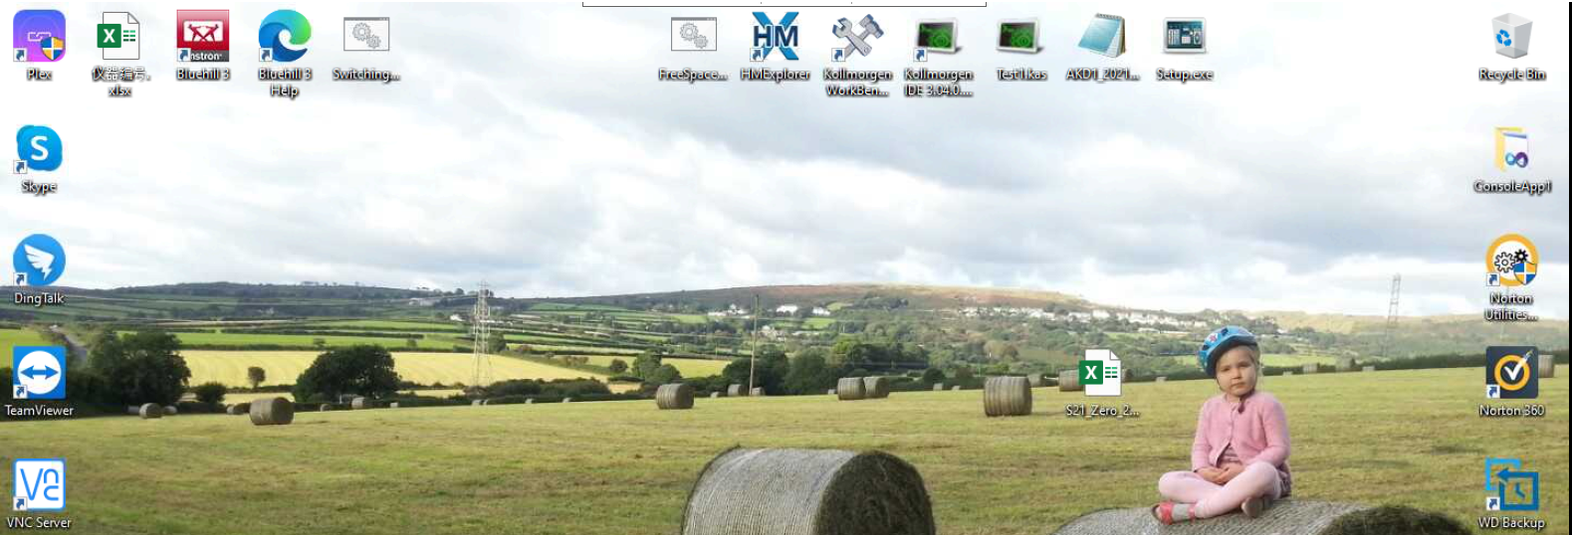

Node-Red GUI for controlling RF switches

1. Click on the BENCH MEASUREMENTS (indicator turns green).

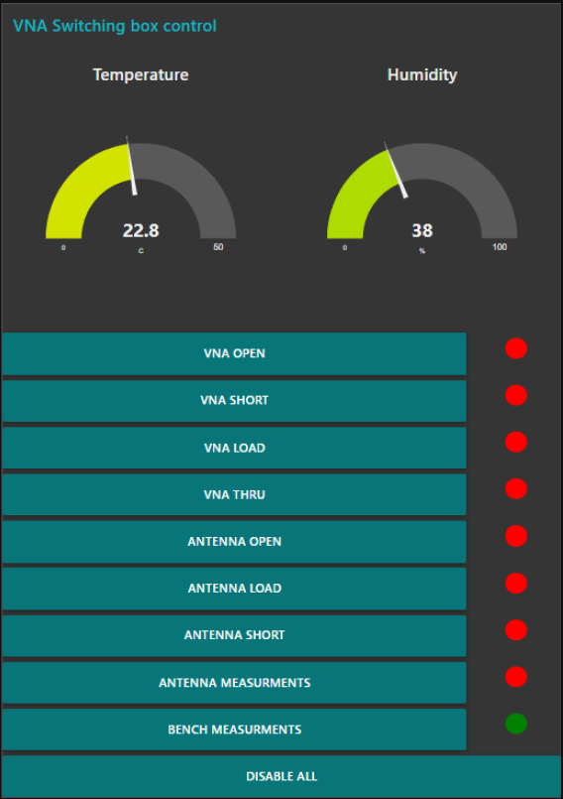 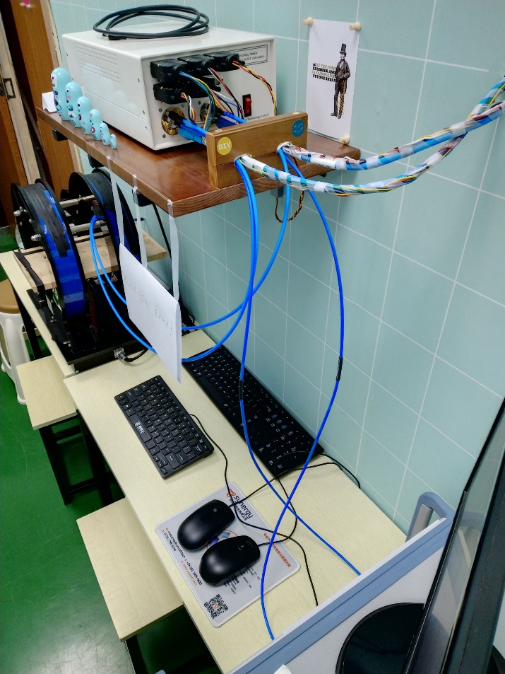

To Antennas

From VNA

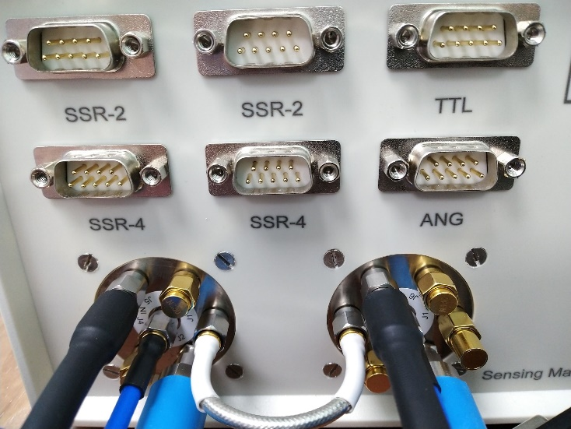 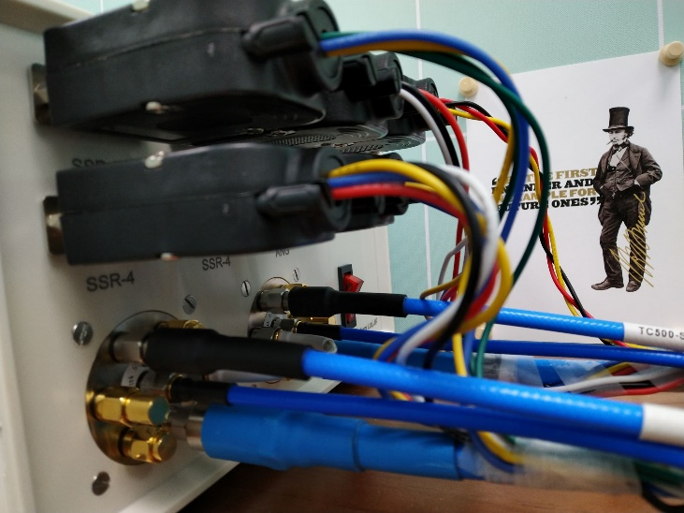

To bench

SOL

To Antennas

From VNA

THROUGH

The box with two SP6T RF switches terminated with coaxial SOLT.

These SOLT terminations are used only for the free space Stage I (see the figure in Introduction). For the impedance measurements, the switches are configured to pass signals further down the bench cables, bypassing the SOLT terminations at the box.

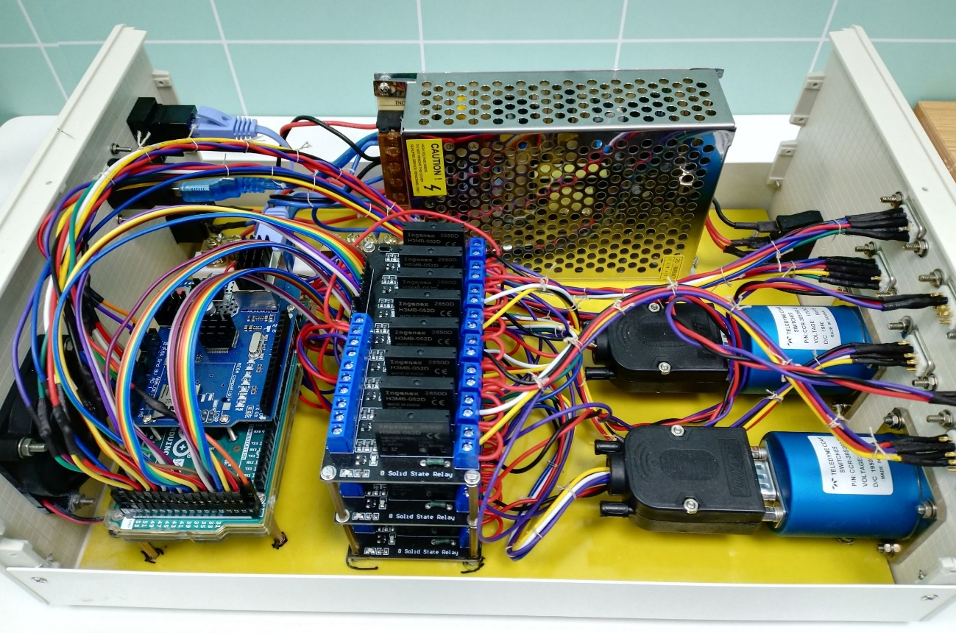

Teledyne LeCroy SP6T RF switches,

0 – 18 GHz, 12 V, 400 mA

GPIO & 12 V outputs

Analog inputs

Solid state relays

5 V TTL

Arduino Mega 2560

GPIO & PWM input/outputs

Analog inputs 0 – 5 V

USB

LAN

12 V, 75 W, DC power supply

The switching box that controls the internal SP6T RF switches terminated with the coaxial SOLT (automatic 2-port VNA calibration) and SP4T RF switches in the antenna pillars terminated with the coaxial SOL (deembedding the long antenna cables).

**Designed and assembled in China by DYK@2020**

1. On VNA, choose the start and stop frequencies (maximum range 100 kHz – 20 GHz or a narrower range), number of frequency points (we usually use 5000, but it is up to you), power (0 dBm or less), IFBW (1 kHz or 10 kHz is recommended), Selectivity (Normal or High).

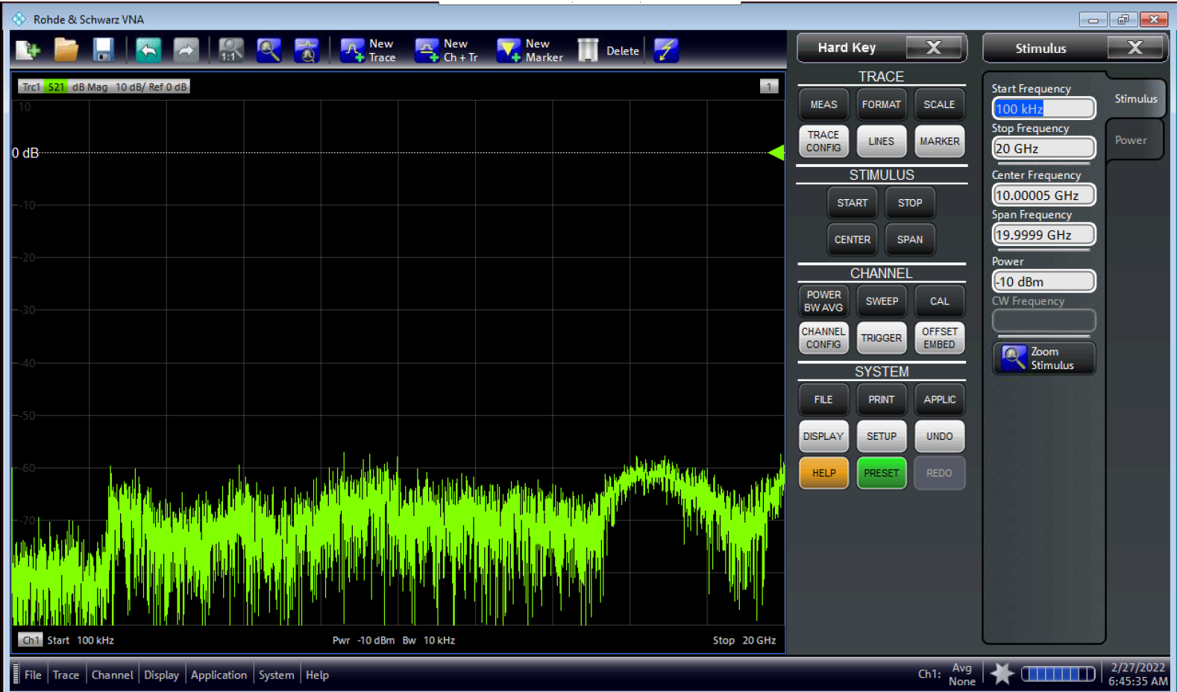

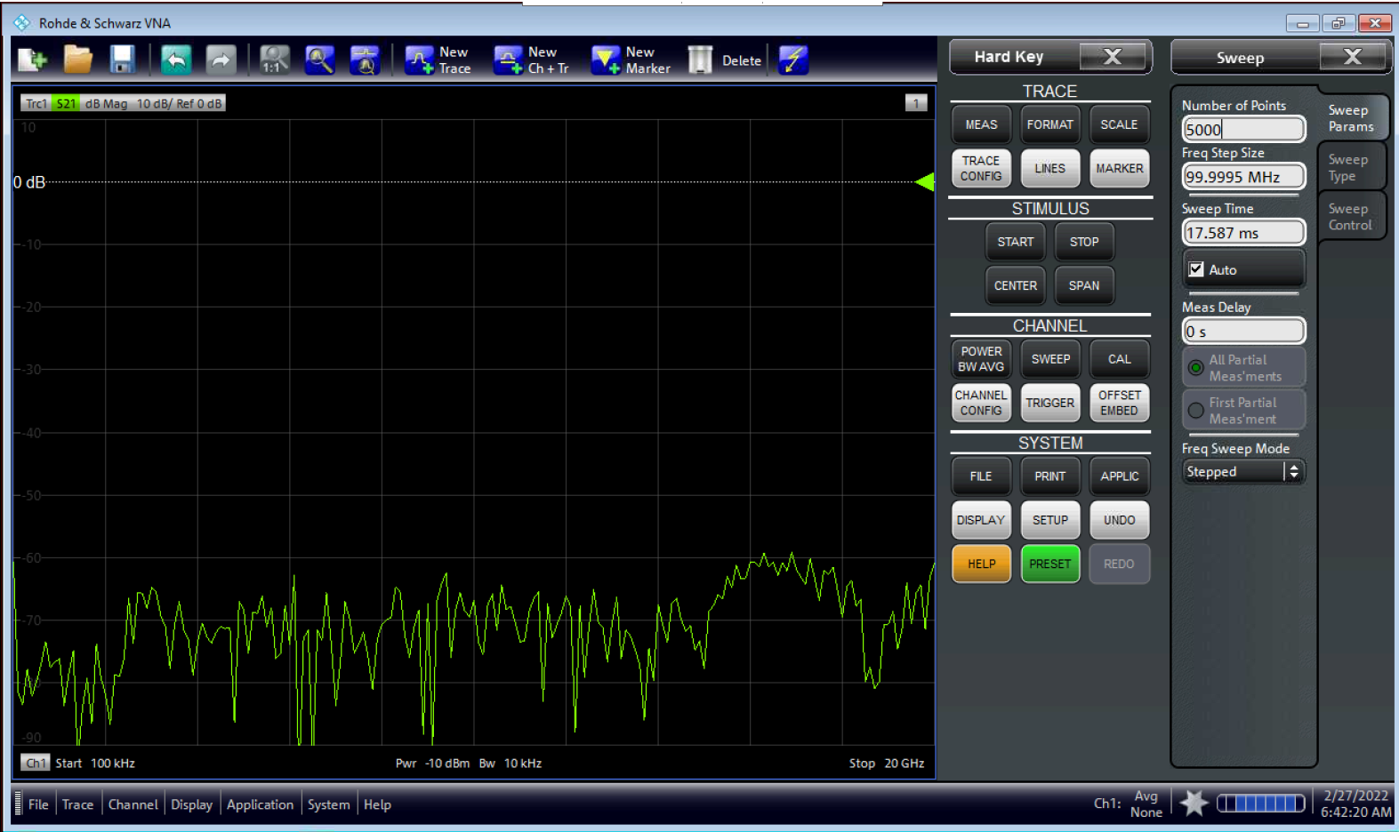

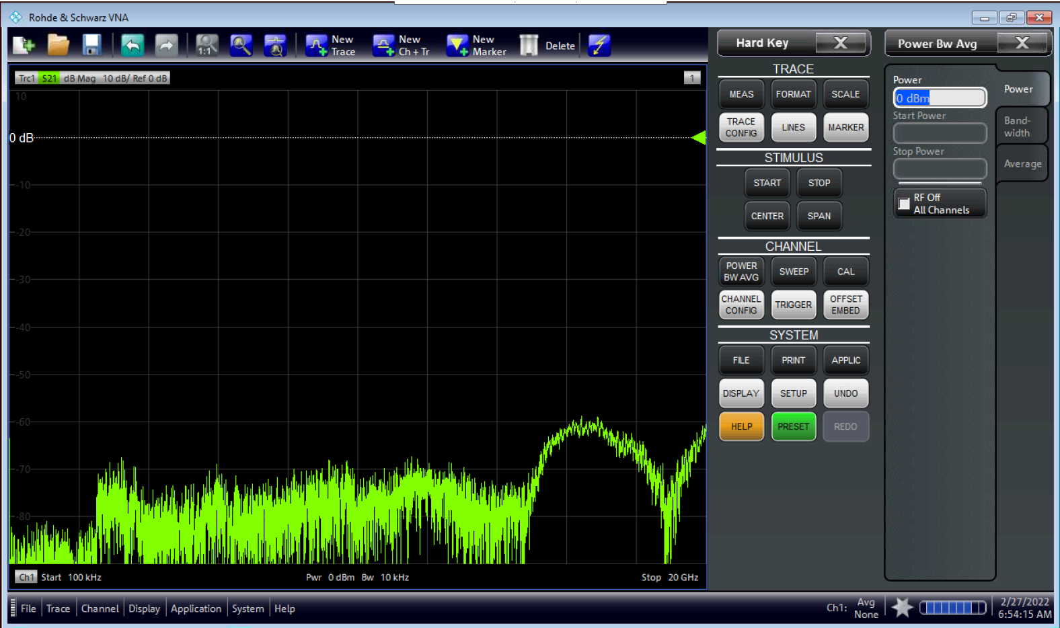

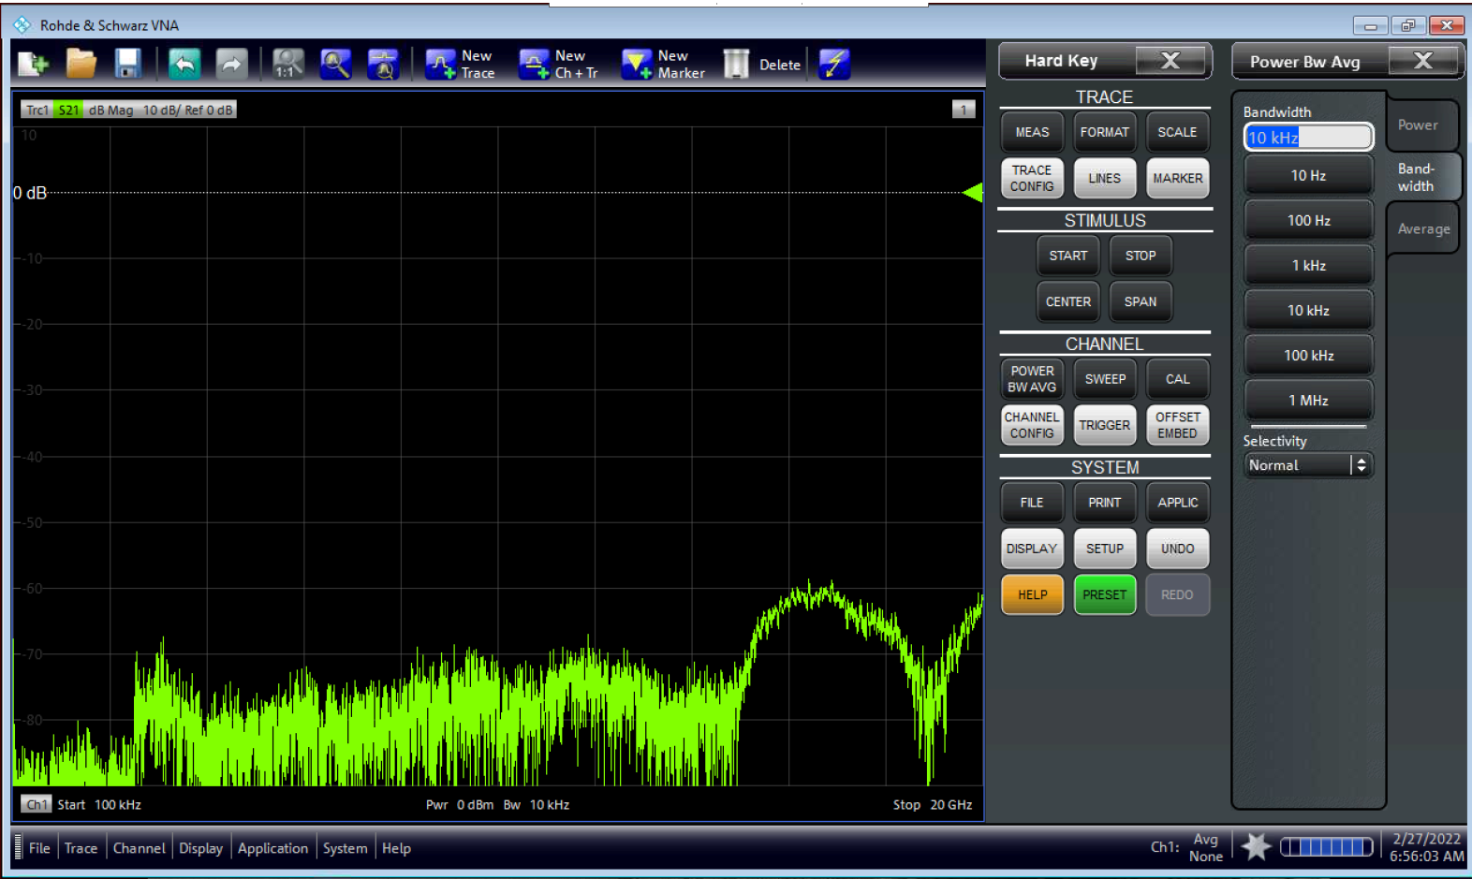

Nornal or High

1. Start performing SOLT – SHORT, OPEN, LOAD, THRU calibration (TOSM in terms of R&S), using the coaxial standards from R&S mechanical calibration kit which are connected to the bench cables.

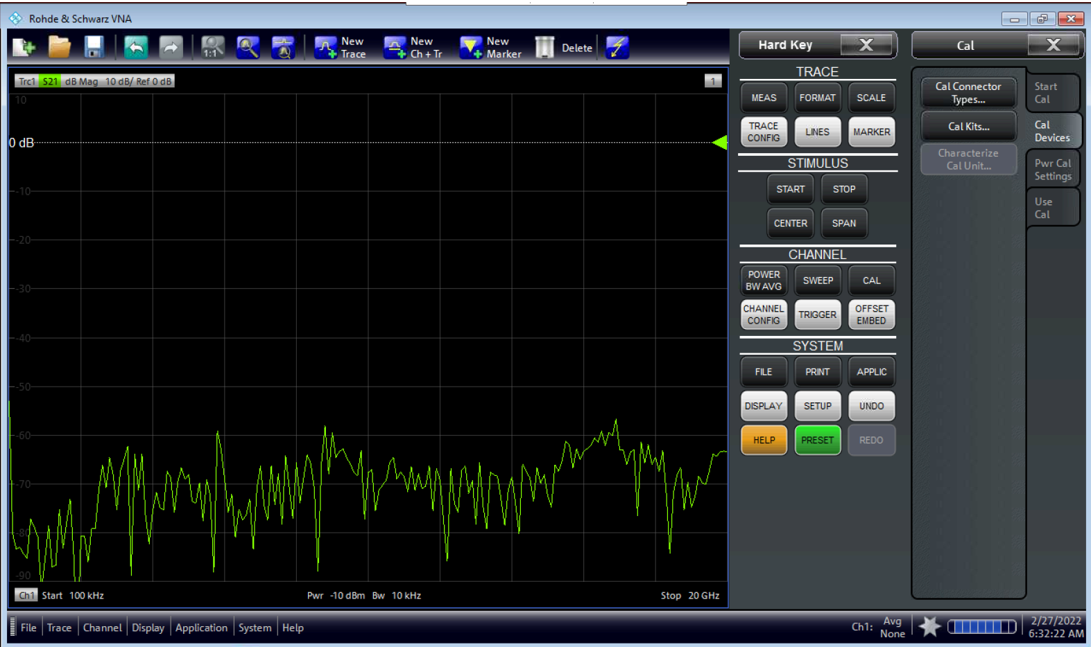

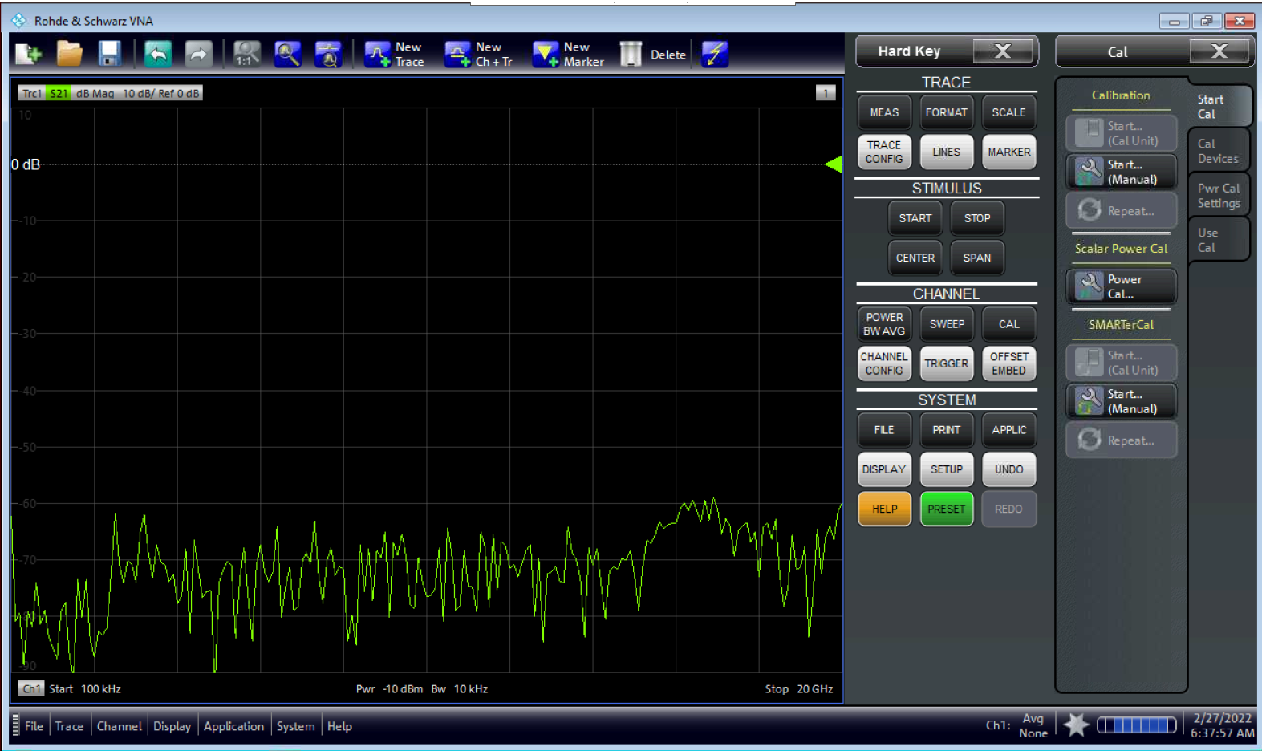

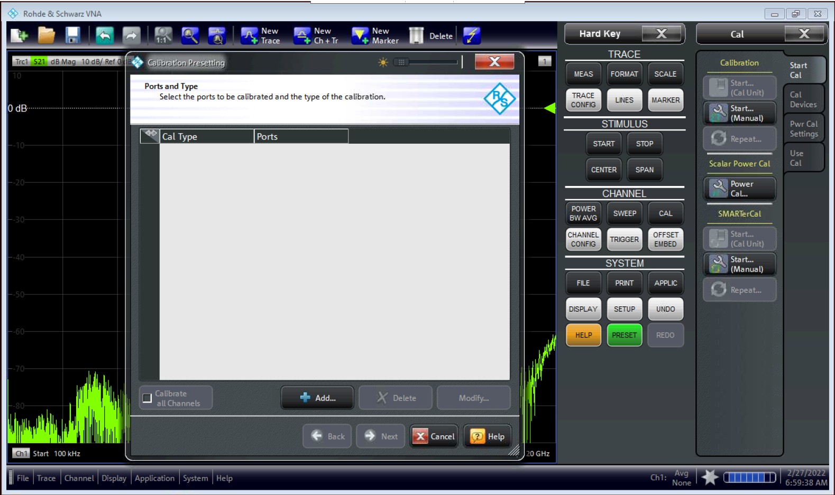

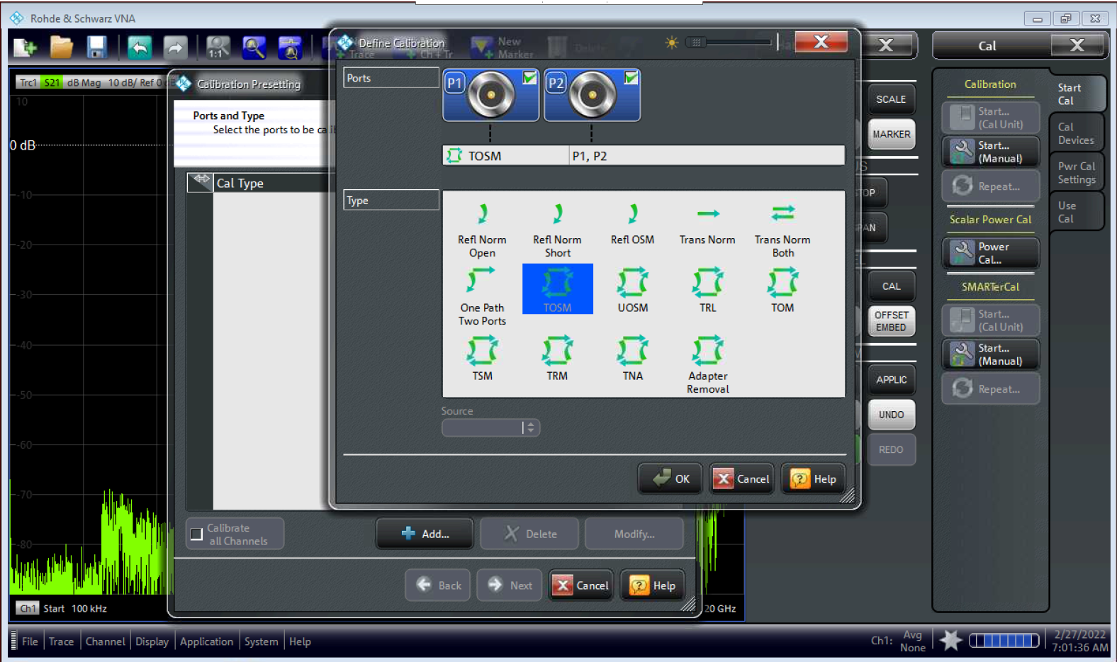

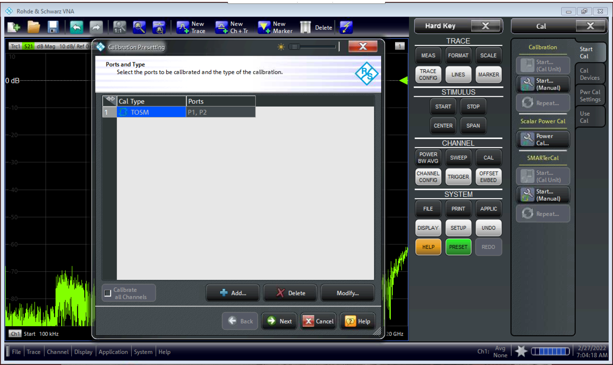

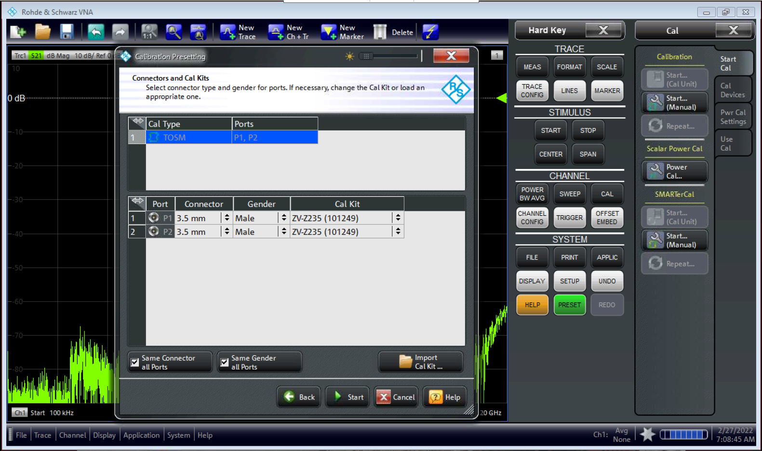

R&S mechanical calibration kit

Check your calibration kit!

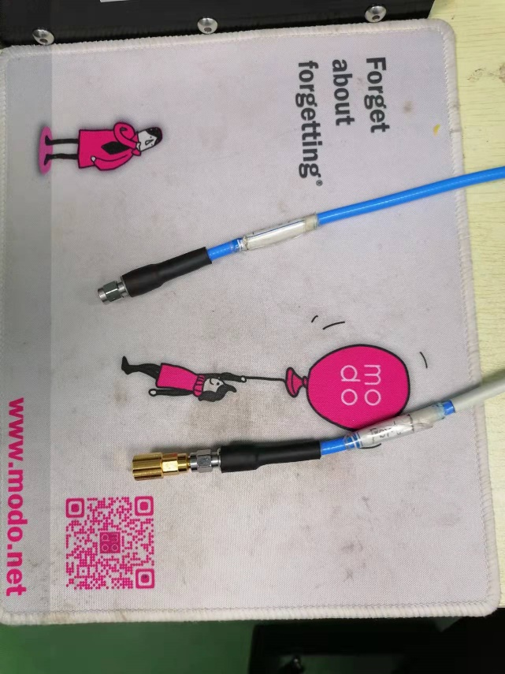 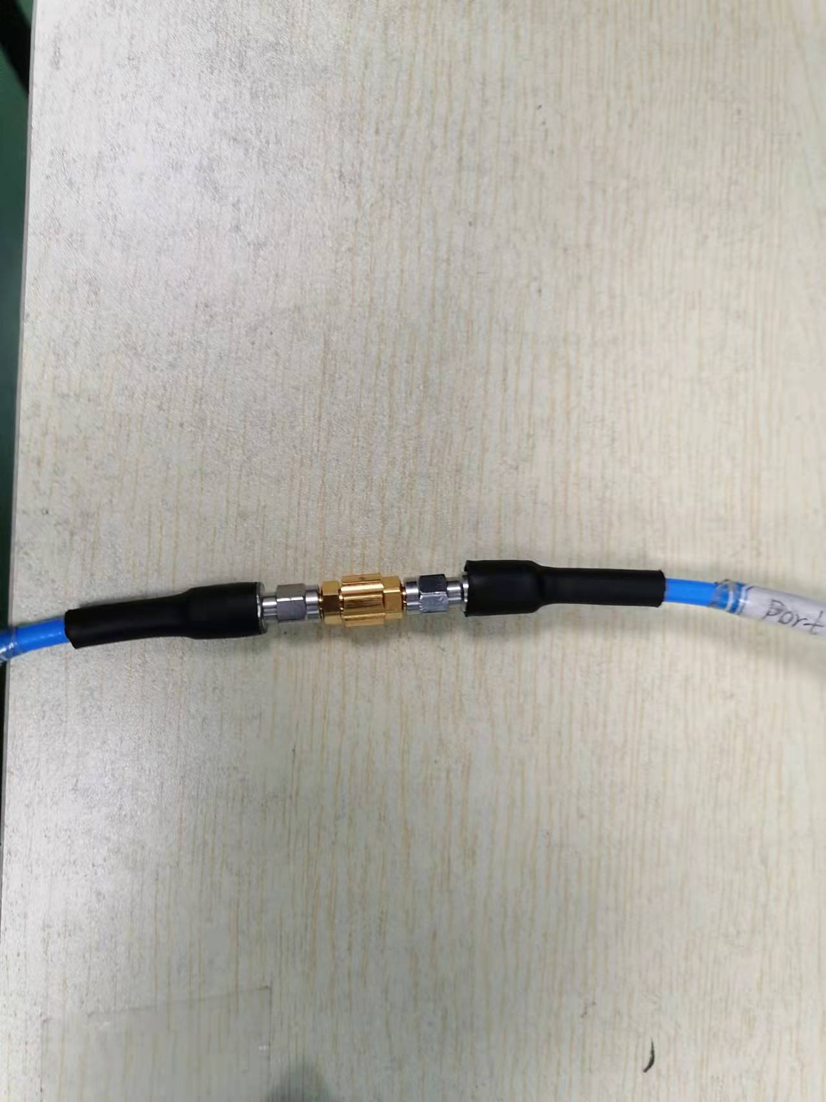

THROUGH

SOL

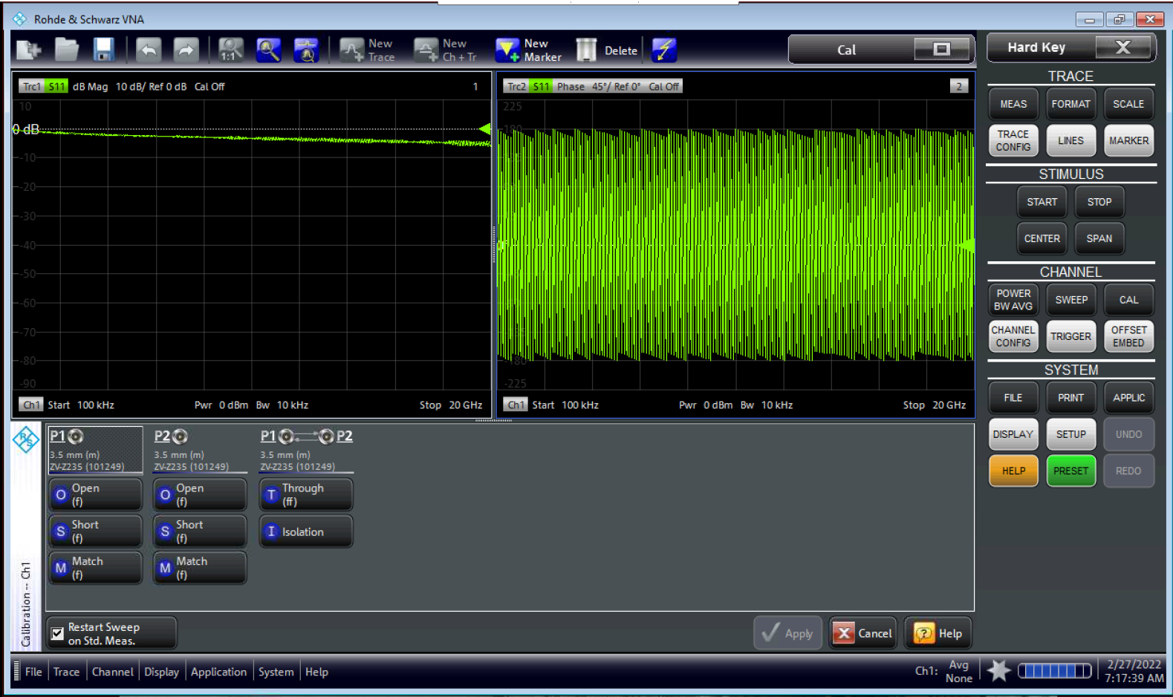

Connect the coaxial calibration standards (SMA female): SHORT, OPEN, MATCH, THRU

Do not forget to Apply the calibration

No need the Isolation

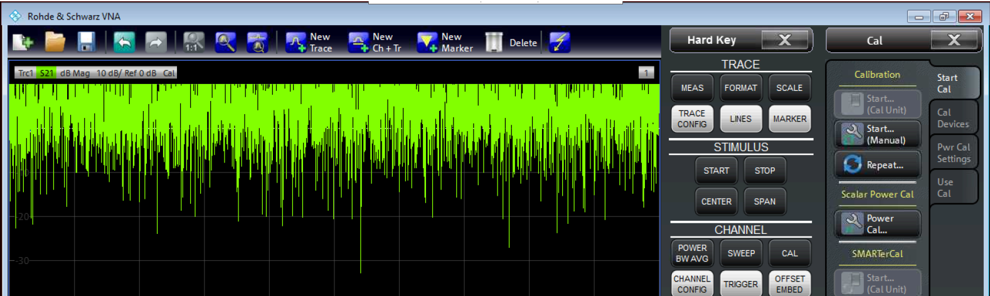

Check that the calibration has been enabled

# Stage II: Fixture removal

S2P files, containing S-parameters of the PCB cells (straight and dogbone), are saved on VNA in the folder:

**C:\Users\Public\Documents\Rohde-Schwarz\Vna\Deembedding\Bench_Cables_PCB_Cells**

Later in this guide, we will explain how to create S2P files for new cells, if necessary.

To activate the deembedding, start with “OFFSET/EMBED” button on the VNA’s front panel.

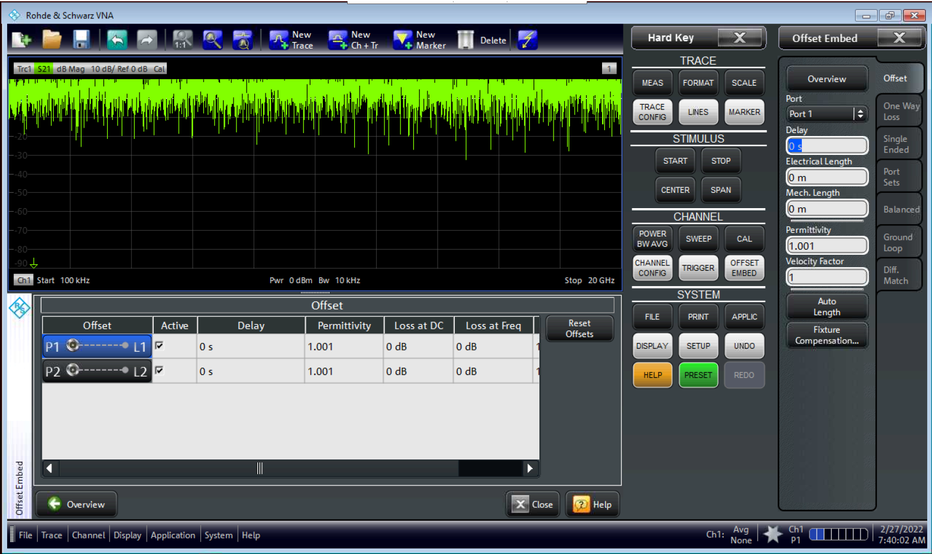

These values (by default)

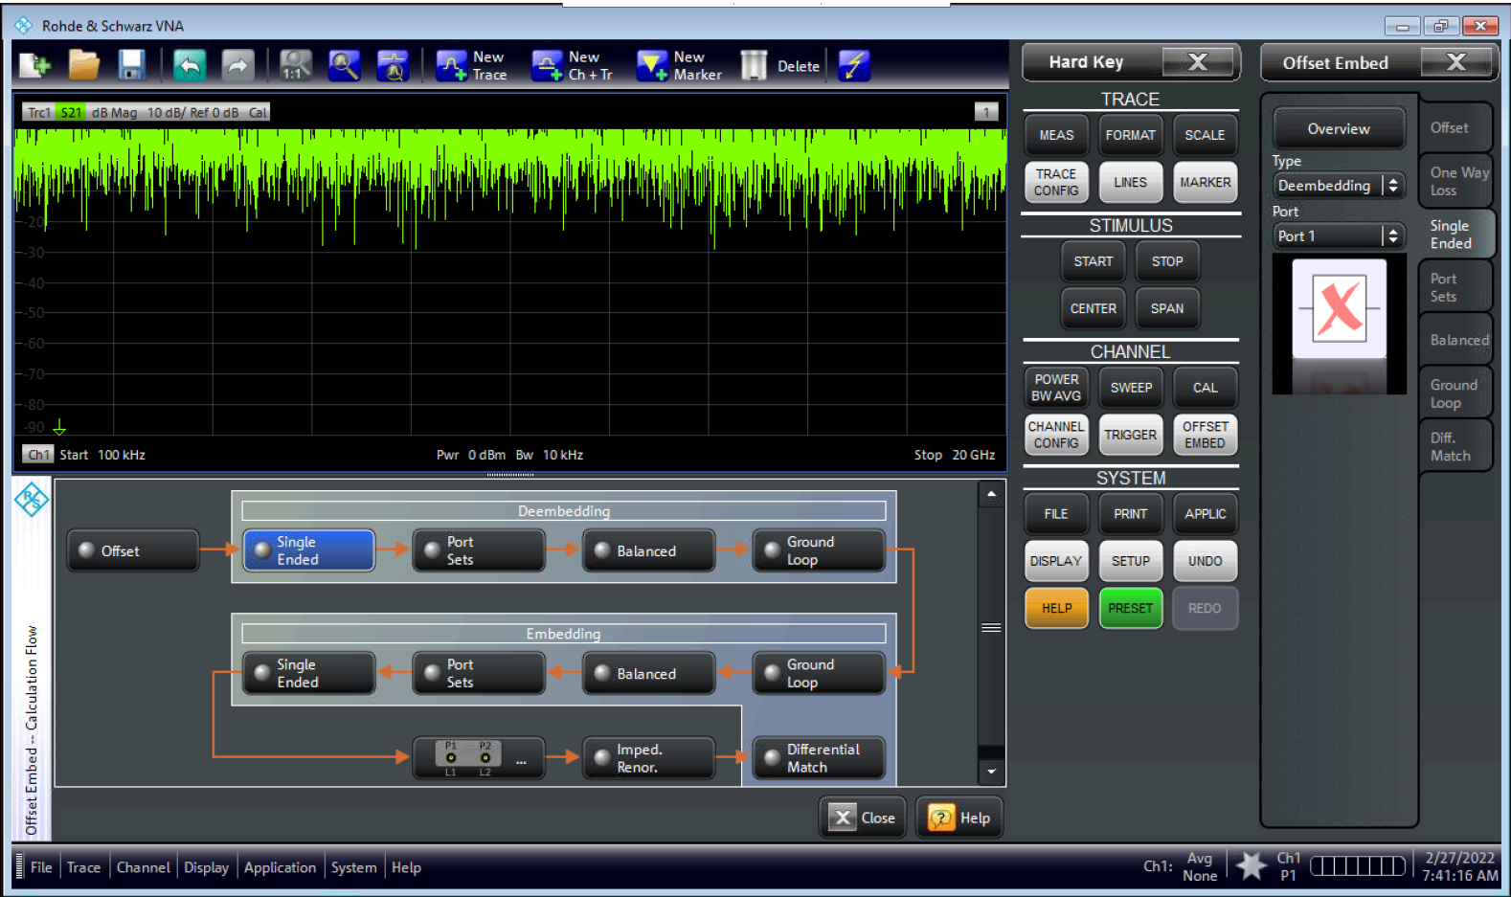

Click

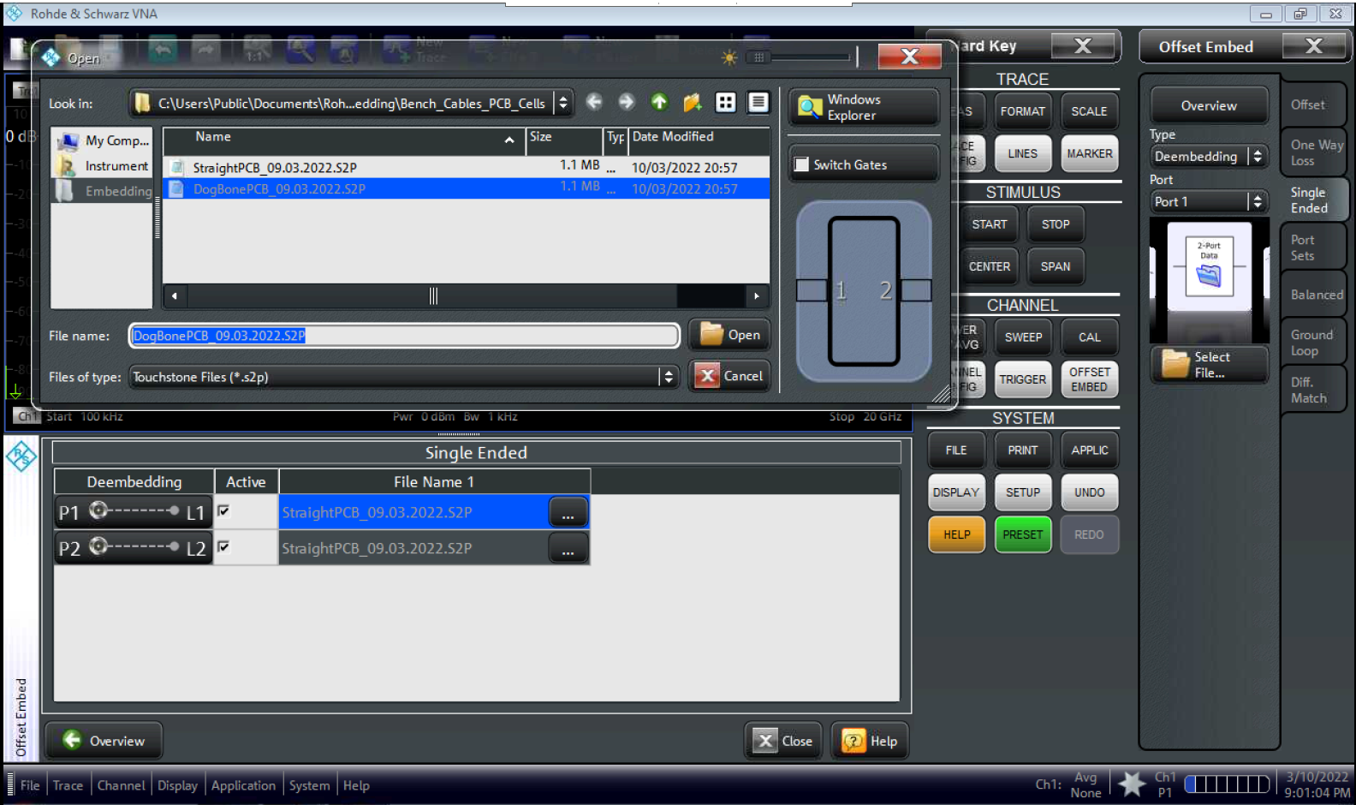

Choose the straight or dogbone cell: the same file for both ports (our PCB cells are simmetrical).

Then, click again on “Overview” and check that “Single Ended” is activated (turns green).

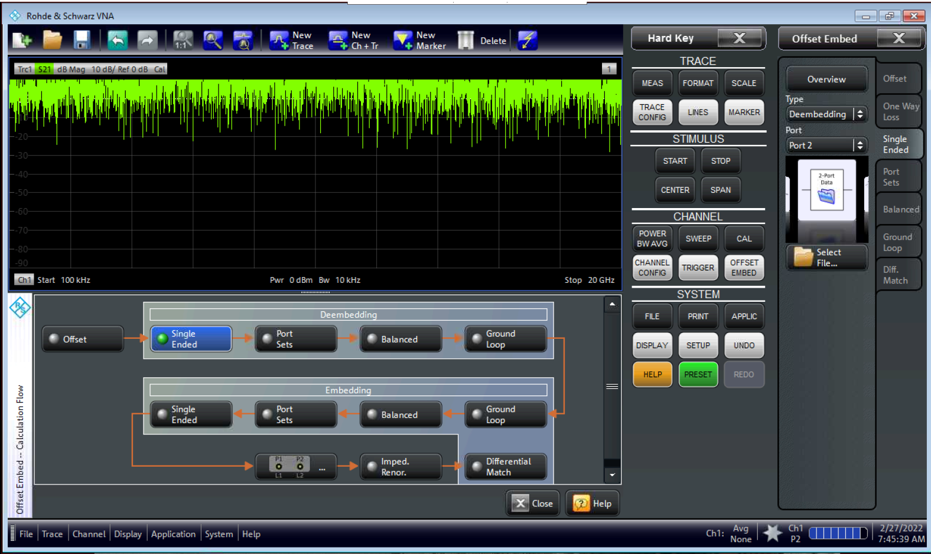

Deembedding has been activated (green)

Calibration is also activated

# Stage III: Delay time compensation

1. After activating the calibration and deembedding, as explained above, you can start measuring the samples (wires or thin films) in the PCB cells. The cells for the various sample lengths that we currently use are shown in the figures below. The measured parameter is $S_{21}$. The cells are 50 Ω microstrips on a dielectric substrate and SMA-Female connectors with a continuous ground plane on the reverse side. The dogbone cell is used for measuring the stress-impedance.[1]

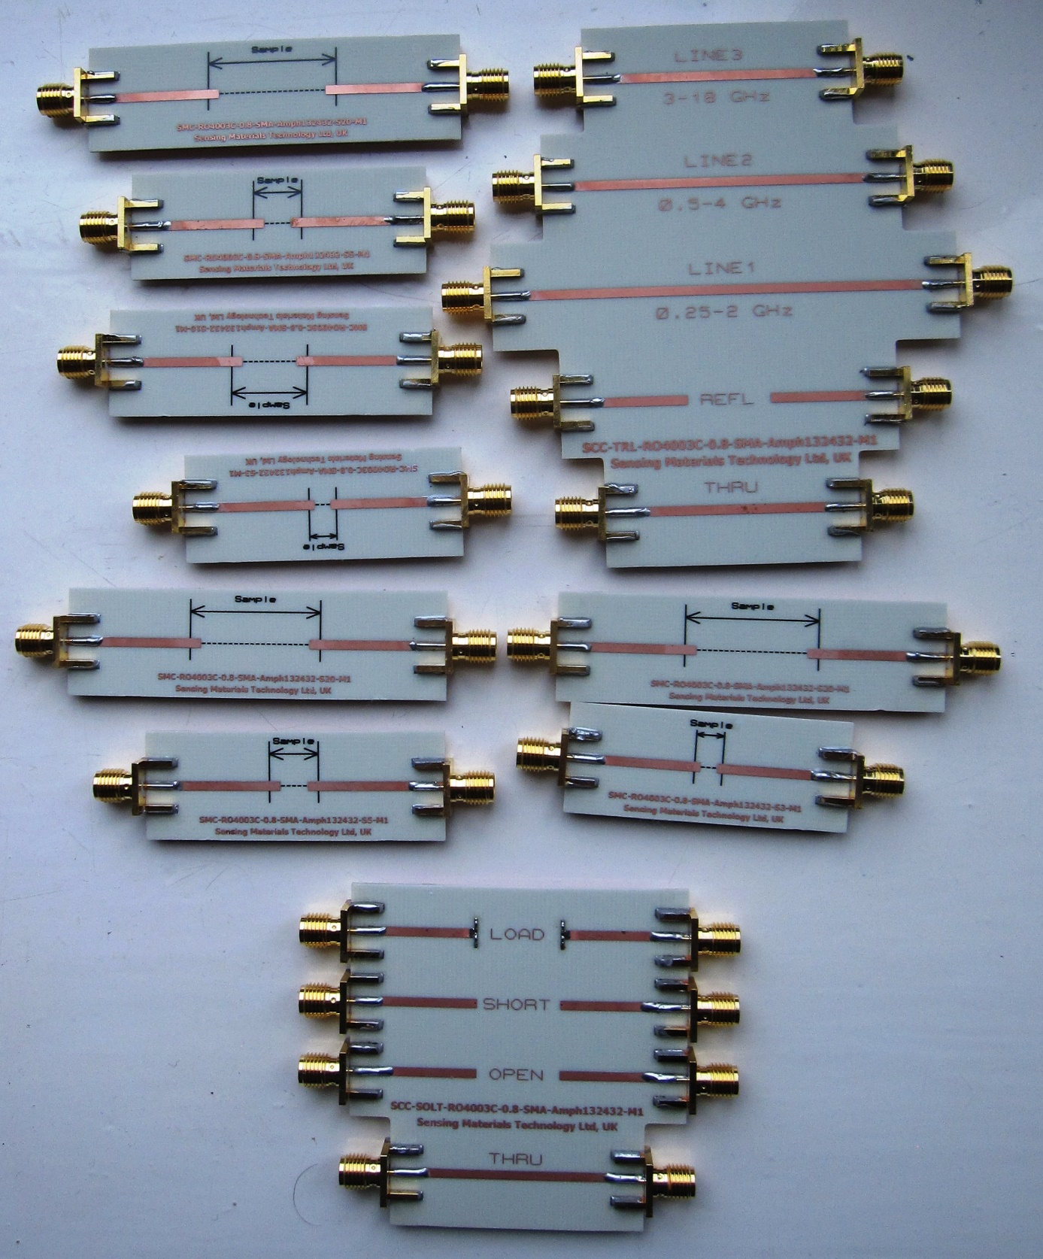

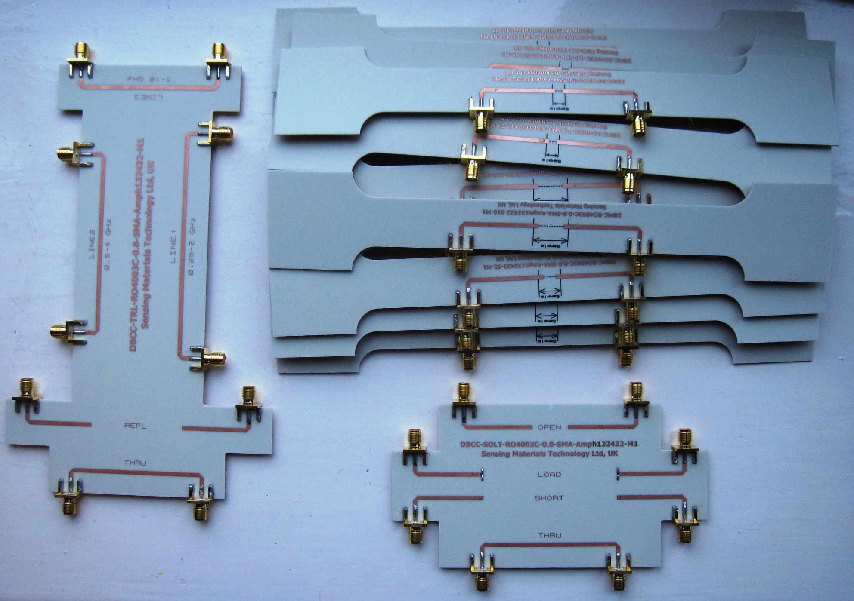

**Designed by Sensing Materials Technology Ltd, UK**

[contact@sensmattech.co.uk](mailto:contact@sensmattech.co.uk)

1. The sample over the ground plane is the waveguide itself, which introduces the phase incursion. When converting the measured $S_{21}$ parameter to the impedance, which is always assumed to be lumped, this phase incursion must be compensated: ${\bar{S}}_{21}=S_{21}×\exp{(}iωΔt)$. Here, where $Δt$ is the delay time along the sample and ${\bar{S}}_{21}$ is the recovered parameter. In turn, the delay time can be derived from the unwrapped phase of $S_{21}$. To do this, we have developed the algorithm in Python, which has been saved on VNA’s PC and in a public repository at GitHub.[4]

Mount the sample under test onto the PCB cell (we use silver paint), connect it to the bench cables, and save S2P file of the sample under the name “S.s2p”. Use the entire frequency range for the sweep, the same as during the calibration. Be sure that cal and deembedding are activated.

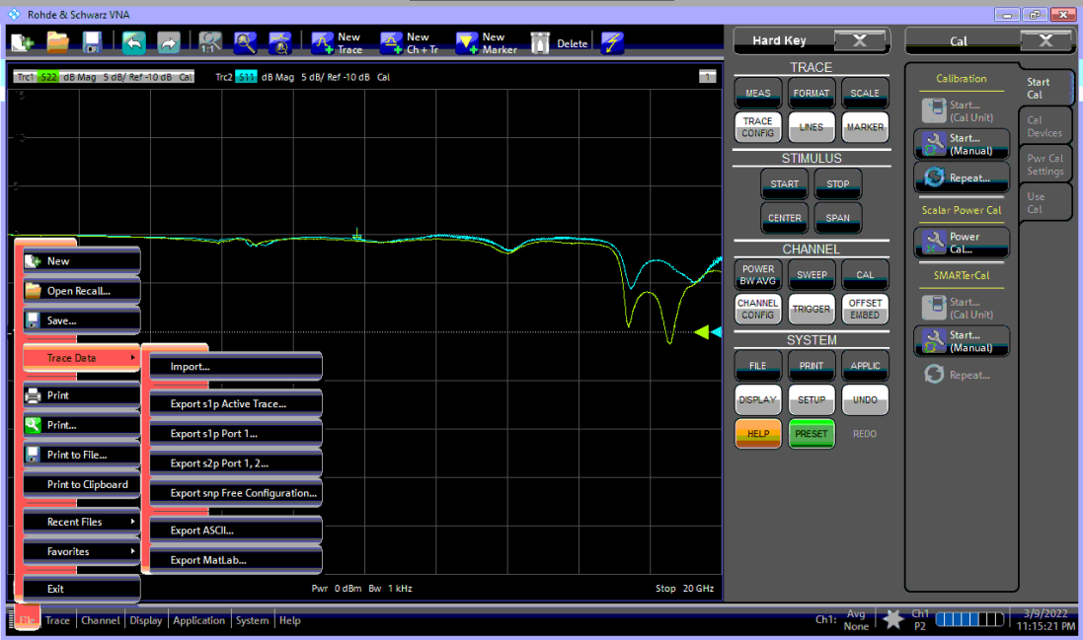

File → Trace Data → Export s2p Port 1,2 → S (file name)

1. Open the saved S.s2p (9 columns) with Notepad and delete the header. Save it.

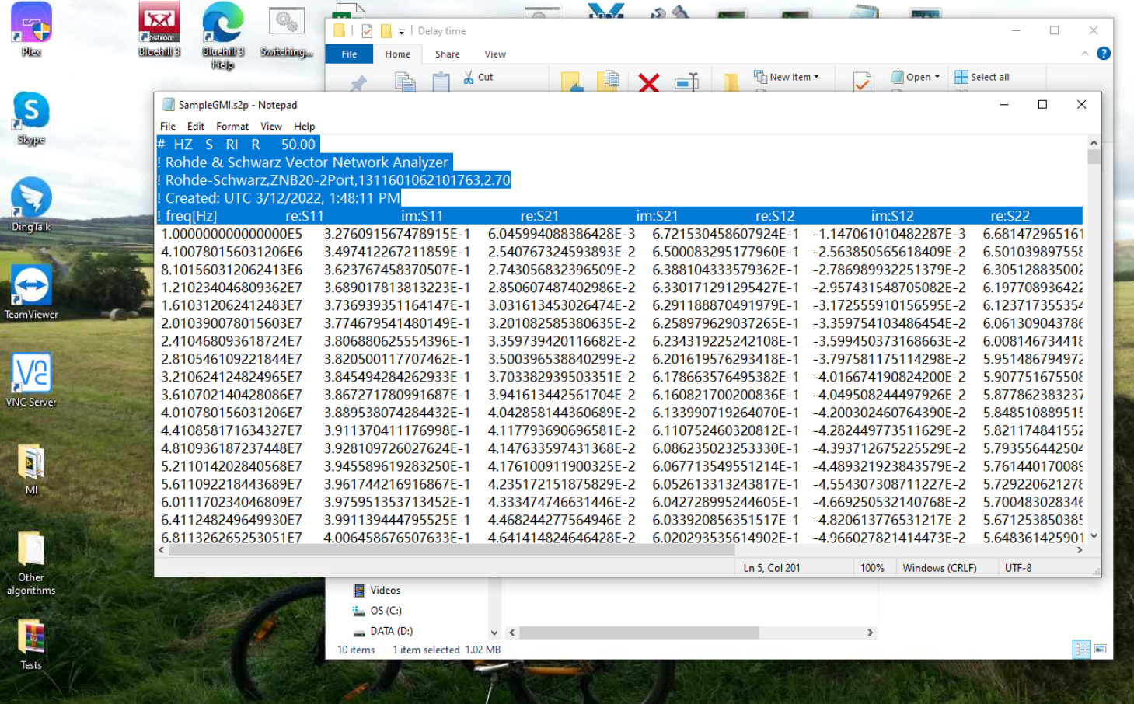

Delete

Delete

1. Open the saved S.s2p (already without the header) in Excel (Data → From Text/CSV). Since we need only the dispersion of $S_{21}$, other columns **except 1, 4, and 5** must be deleted (first, delete the last four columns, and then the second and third columns). Do this and then save the file as S.csv with the comma delimiter. Finally, open S.csv in Excel and the delete the header (Column 1, Column 2, …) leaving only the numbers in the three columns. Save it. Now, the file S.csv is ready for the numerical calculations using our interactive algorithm in Python (“Delay time”).
2. On the VNA’s PC we have installed PyCharm IDE to run Python programs.[6] Run “Delay time” algorithm as shown below. It does not have GUI.

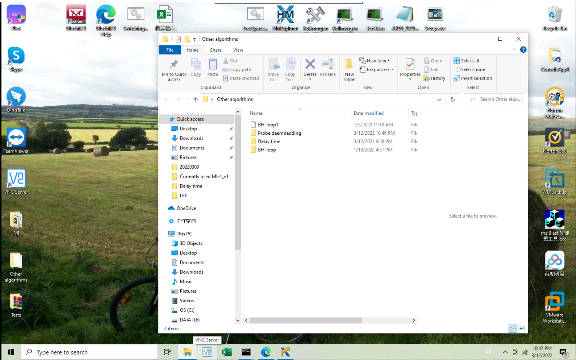

Click on “main.py”, PyCharm will start the project that includes several Python modules

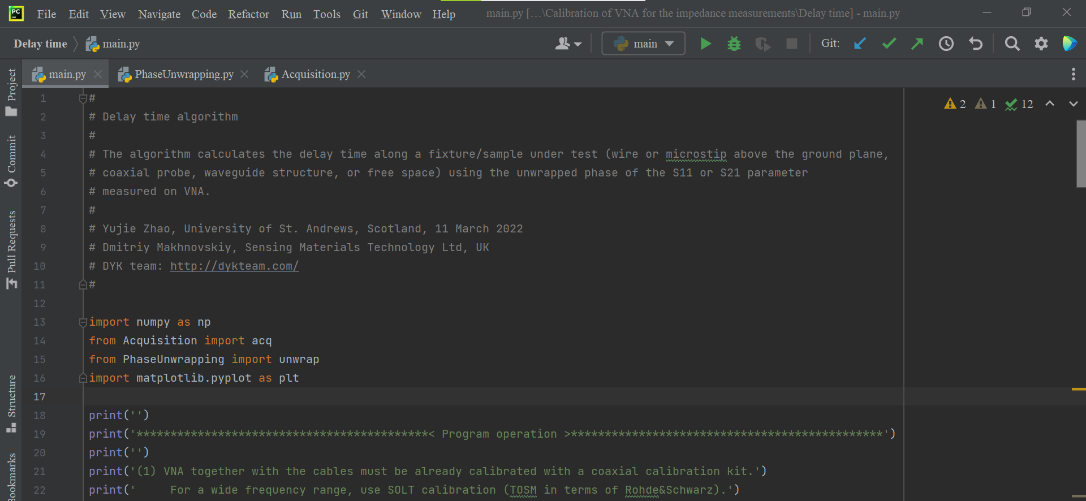

DO NOT CHANGE ANYTHING IN THE PROGRAM BODY!

Run the program

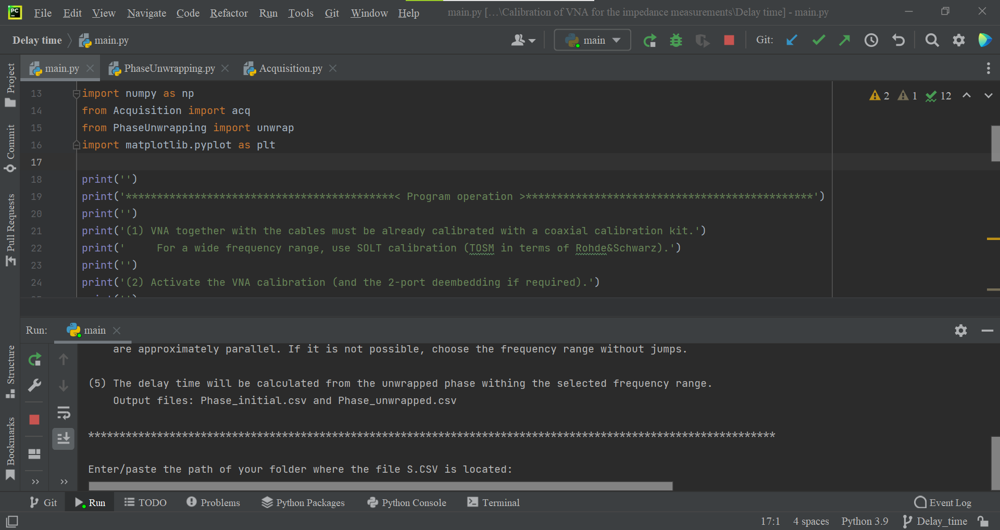

Copy and paste the full path to S.csv and then push Enter.

Then, follow further instructions.

Stop

DO NOT CHANGE ANYTHING IN THE PROGRAM BODY!

Interactive window

Enter/paste the path of your folder where the file S.CSV is located: (copy & paste the full path to S.csv)

Please choose the delimiter used in S.CSV ( , ; tab space): , (choose the comma “,”)

1. First, the program will draw the raw phase dispersion of $S_{21}$, as shown below. We must choose the proper frequency range for calculation of the delay time.



We suggest comparing the program graph with the VNA display to make sure you have prepared the S.csv file correctly.

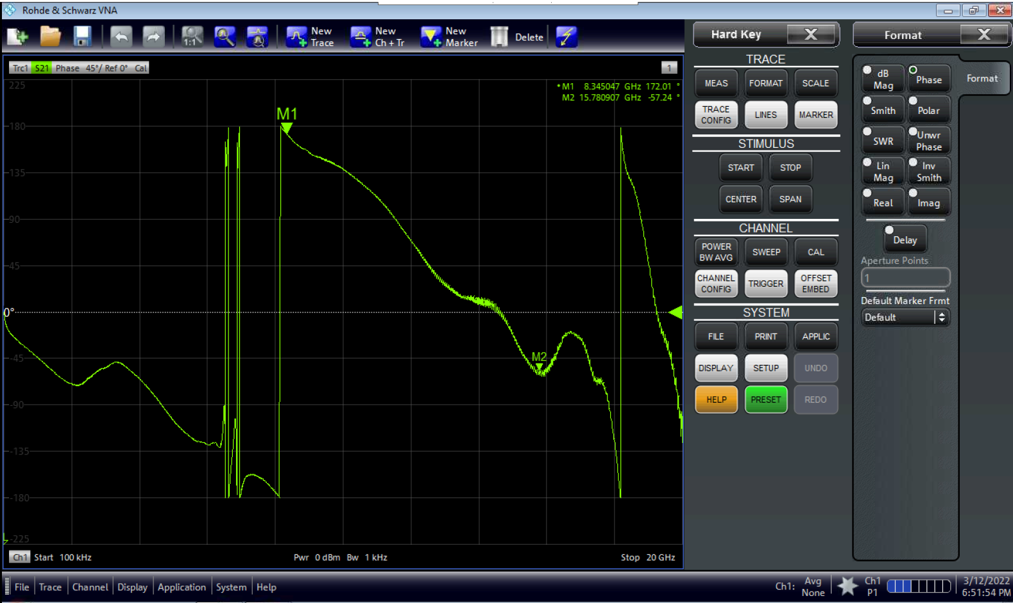

S21

1. Choose the frequency range, as explained above, and close the graph. Then enter these values (use the science format “**.**e**”), each time pushing Enter.

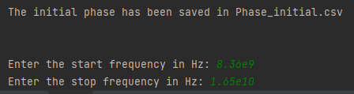

The program will draw the selected part of the phase dispersion to check the correctness of the choice.

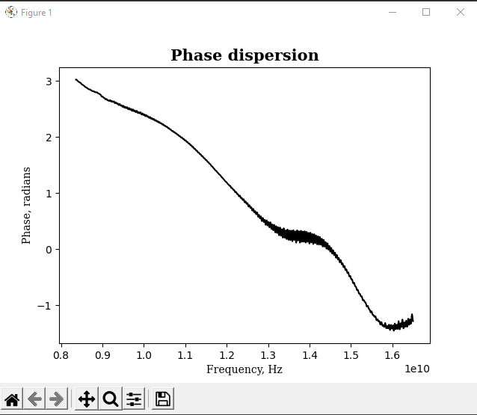

1. Close the previous graph. After that, the program will draw the next one with the so-called unwrapped phase, which will look the same if no jumps were included.

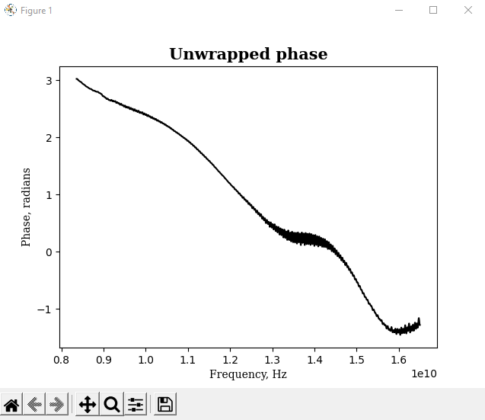

1. Close the previous graph. The program calculates the delay time $Δt$ along the sample from the slope of the straight trend line: $Δt=\left|a\right|/(2π)$, where $φ≈a×f+b$ is the trend line for the unwrapped phase and $f$ is the frequency. The value of $b$ introduces a slight vertical shift in the trend line and does not play any role.

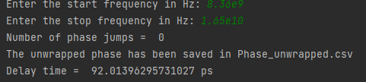

The delay time is used in our LabVIEW programs for measuring the magneto-impedance and the impedance dispersion. However, it needs to be further adjusted, as will be explained later. Note that the program also saves the raw and unwrapped phases in the CSV files.

1. The quality of the phase dispersion depends on the design of the PCB cell. Quite unexpectedly, but we found that the dogbone cell, despite its more complex design, exhibits better phase dispersion up to 13 GHz or even higher, as shown below. For this dispersion, we could include the single middle jump.





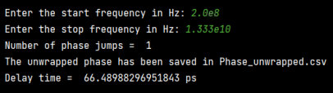

1. VNA has a function to estimate the delay time along a fixture. However, when trying to narrow the frequency range to select the correct part of the phase dispersion, spikes will appear due to numerical uncertainties caused by the 2-port deembedding. These spikes will prevent the phase from being unwrapped directly on the VNA. Thus, this function on VNA turns out to be useless in our case. We have to use an external algorithm.

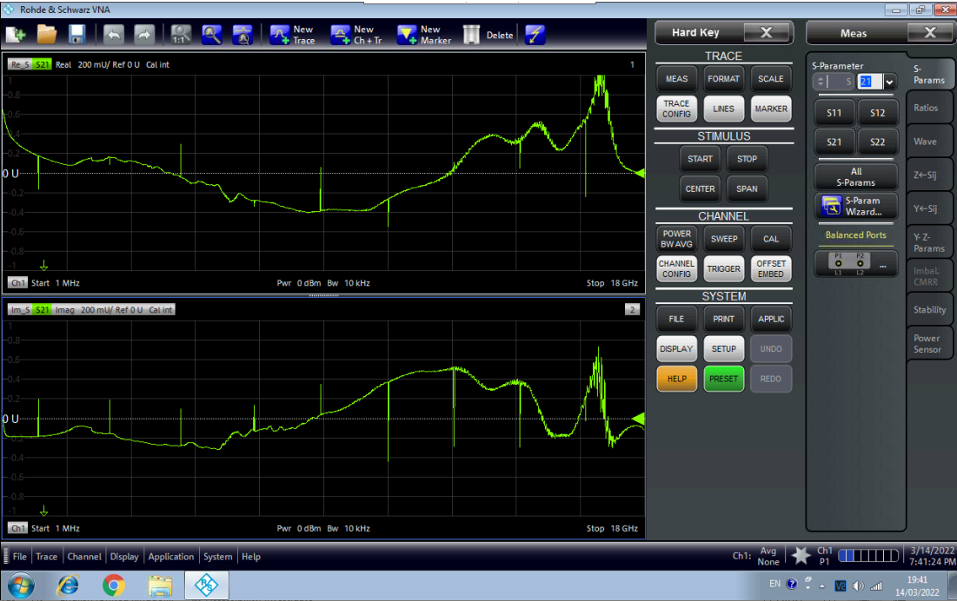

Cal and deembedding are activated

Narrower frequency range than calibration range

Spikes due to numerical uncertainties caused by the 2-port deembedding

1. To further tune the delay time along the sample, we should use the impedance dispersion calculated from $S_{21}$. The main criterion for tuning is the positiveness of the real part of the impedance for the entire frequency range. In the case of a ferromagnetic wire exhibiting resonance, we can also control the imaginary part, which must be negative after resonance.



The spikes can be easily suppressed using a smoothing spline interpolation.

On the VNA’s PC we have several LabVIEW programs to measure the impedance dispersion on a R&S VNA. You can choose any of them for tuning $Δt$: play with $Δt$ around its calculated value.

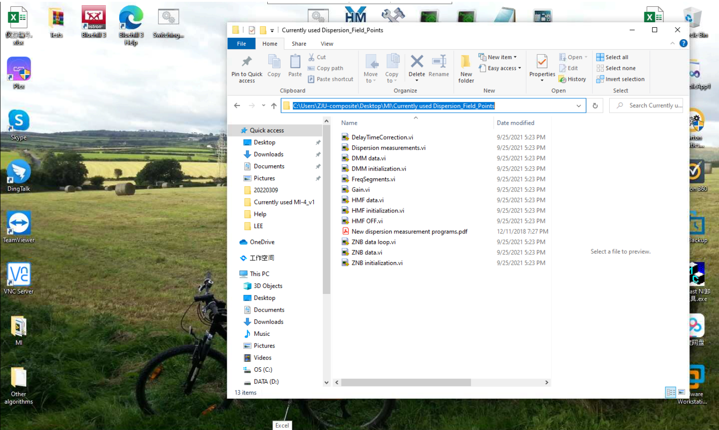

Run LabVIEW 2015

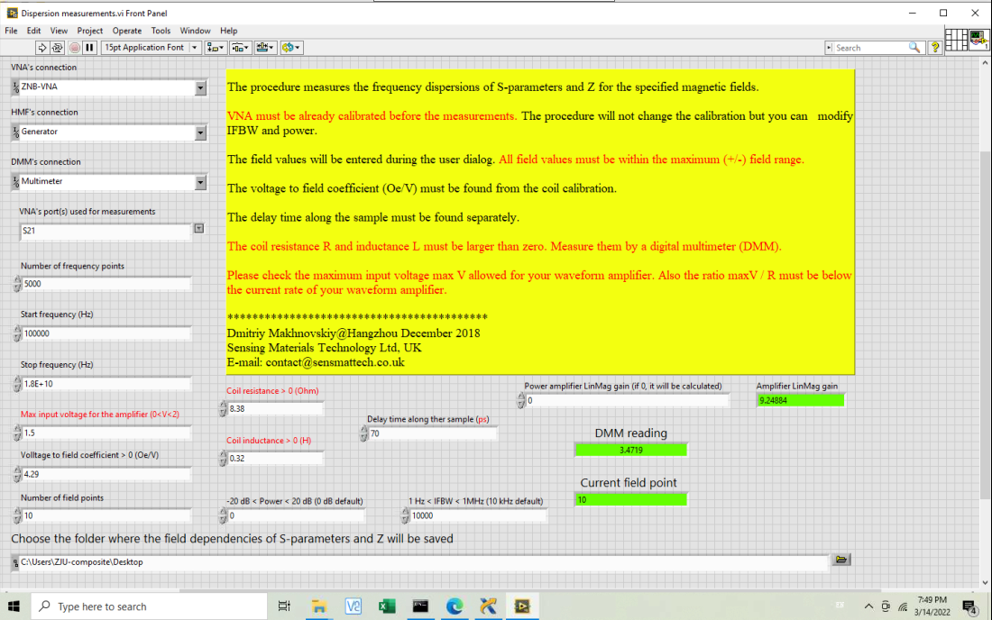

Program may show error if you choose a folder other than Desktop. This is a specific LabVIEW’s issue we could not repair so far.

One field will be enough when tuning

1

Try a few values around the already calculated Δt to test the impedance dispersion against the real and imaginary parts as explained above.

Put some value here, e.g. 9, to avoid the gain calibration and thus save time. This is only when tuning the delay time!

During measurements, communication with devices may be lost, most frequently with R&S Digital Multimeter (DMM). In this case, you can try to reconnect using NI MAX. Alternatively, switch off DMM, then switch on again, run NI MAX, and refresh Network Devices. Ask someone who has worked with our LabVIEW programs if you run into problems.

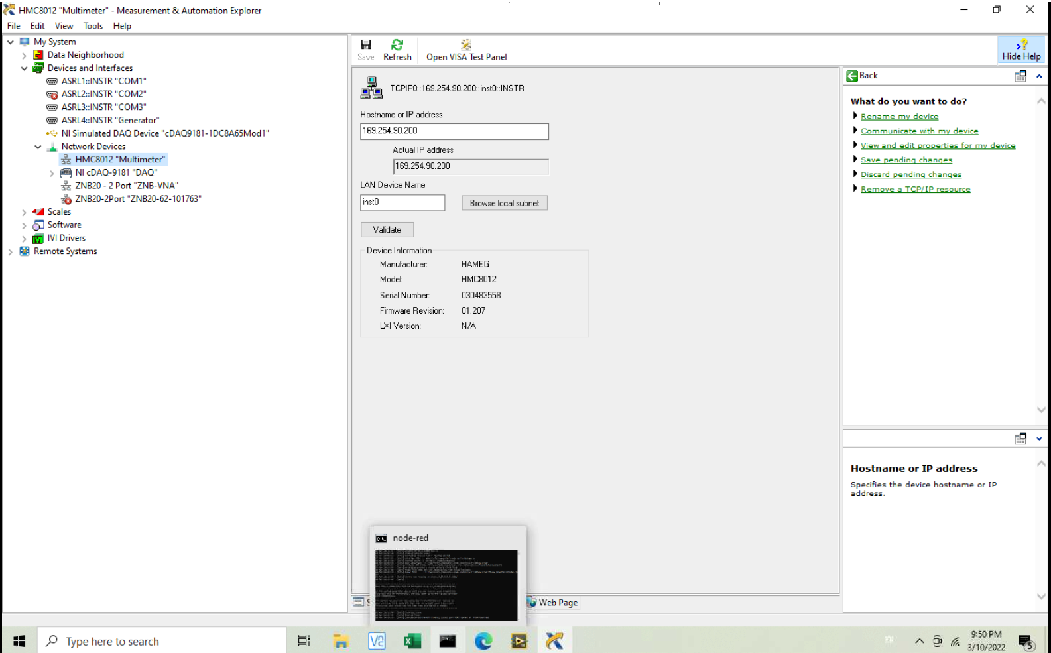

1. For your convenience we have developed an Python algorithm for calculating the impedance dispersion from the saved S.csv (see Chapter (2) in this section).

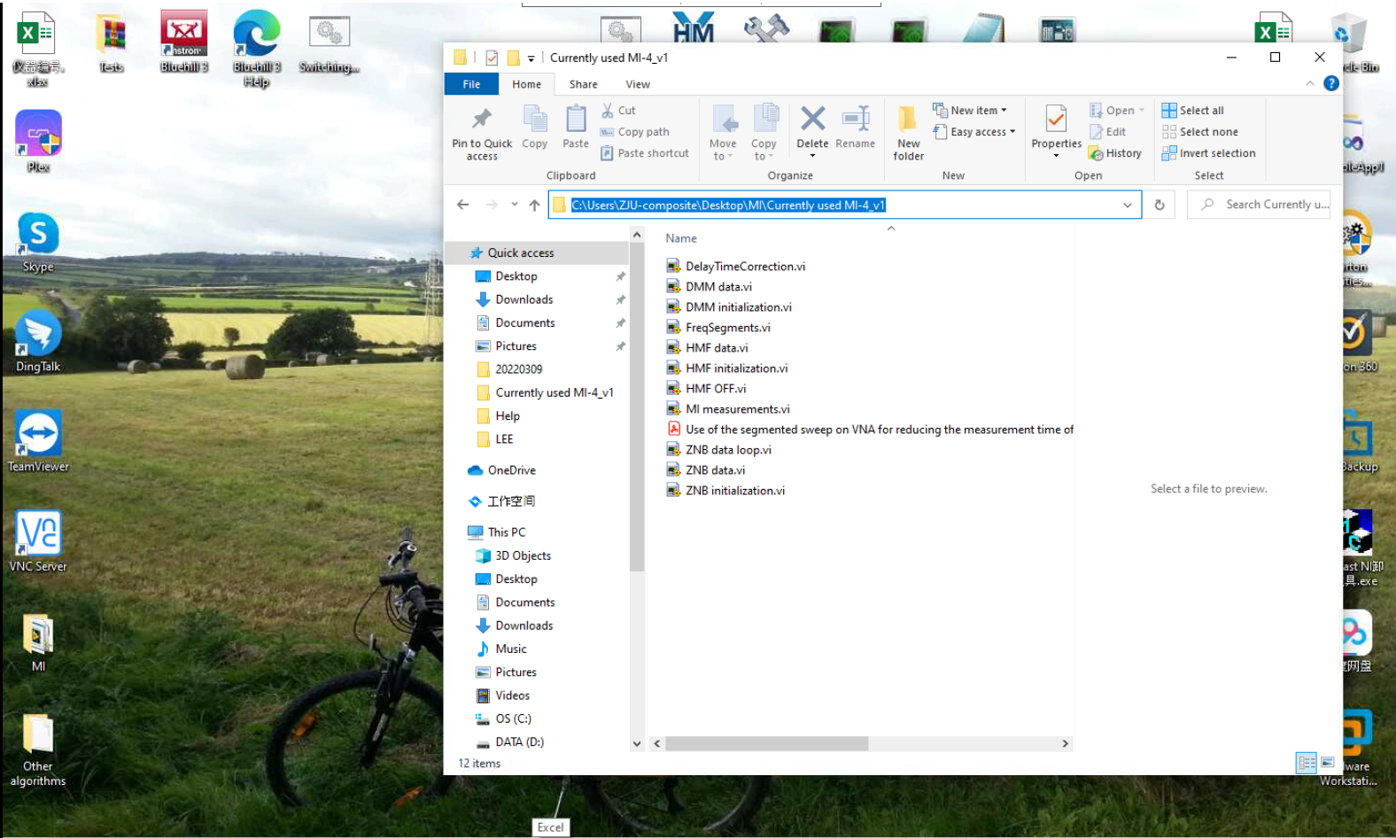

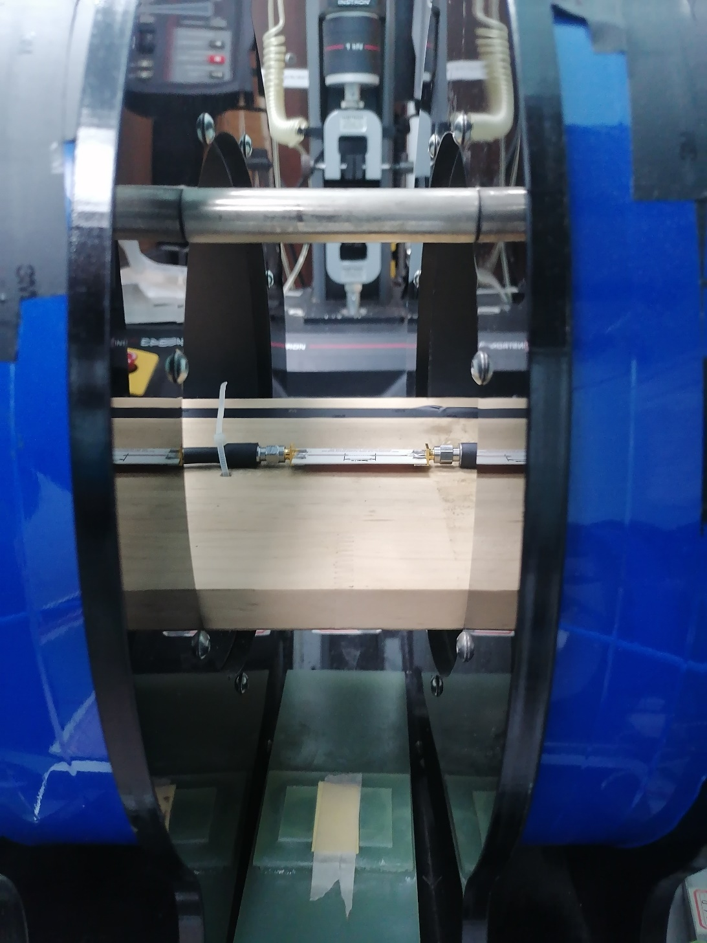

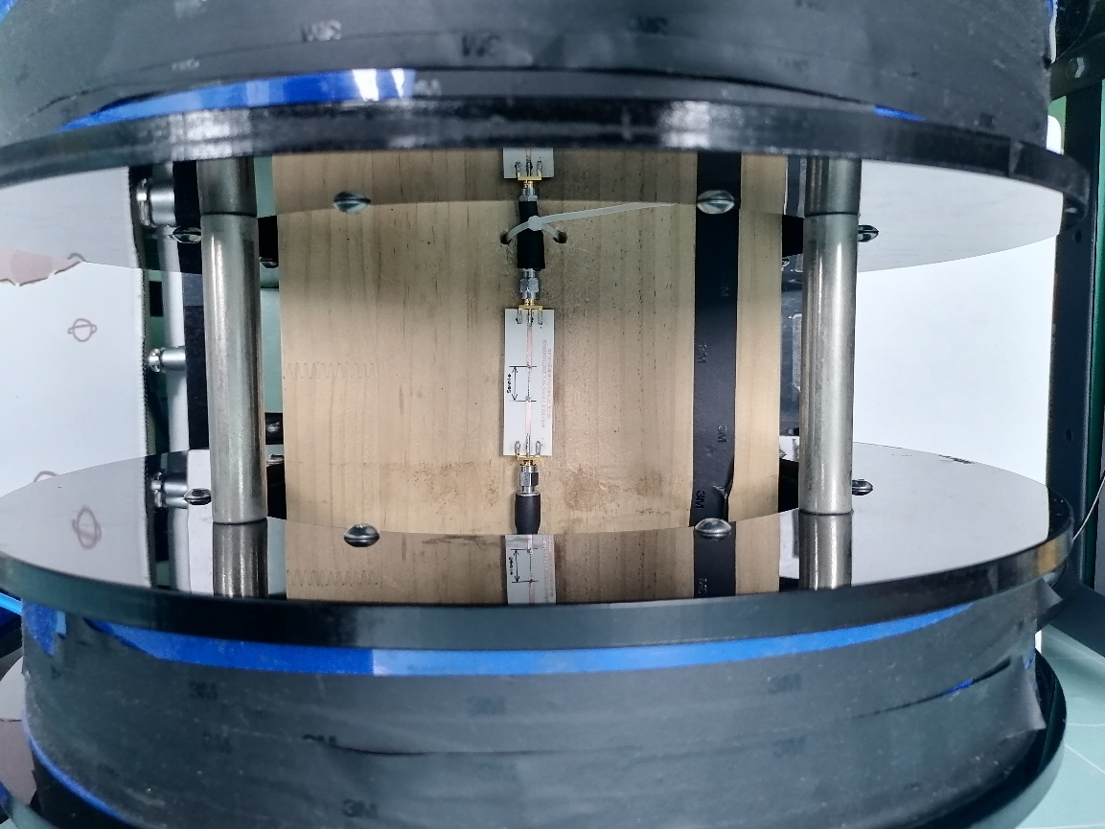



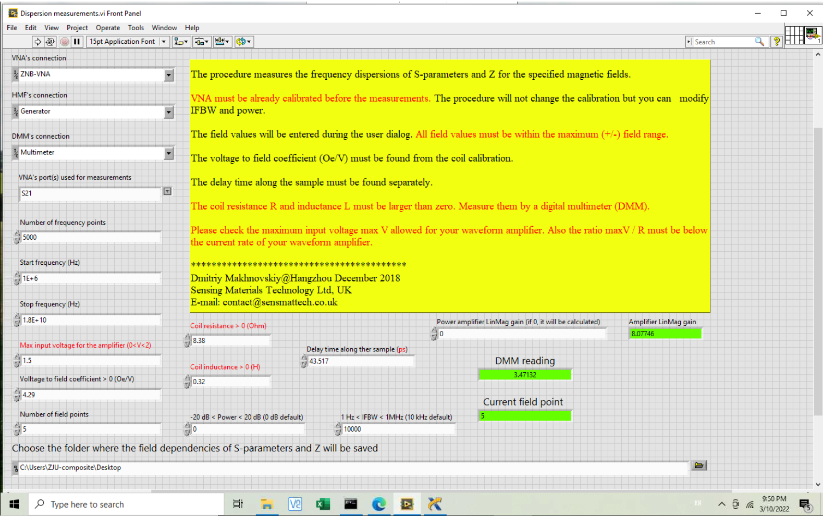

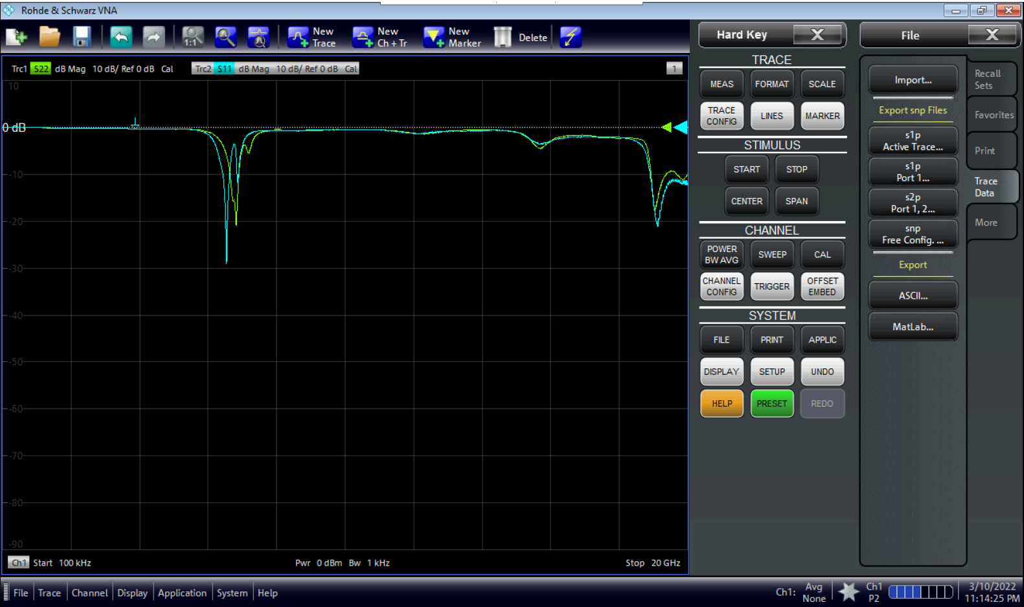

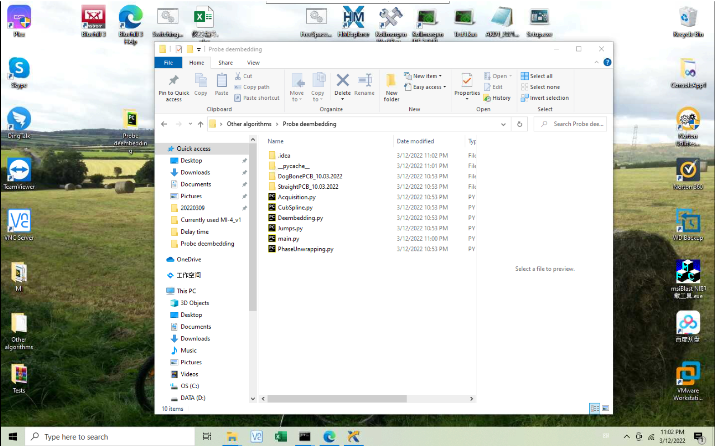

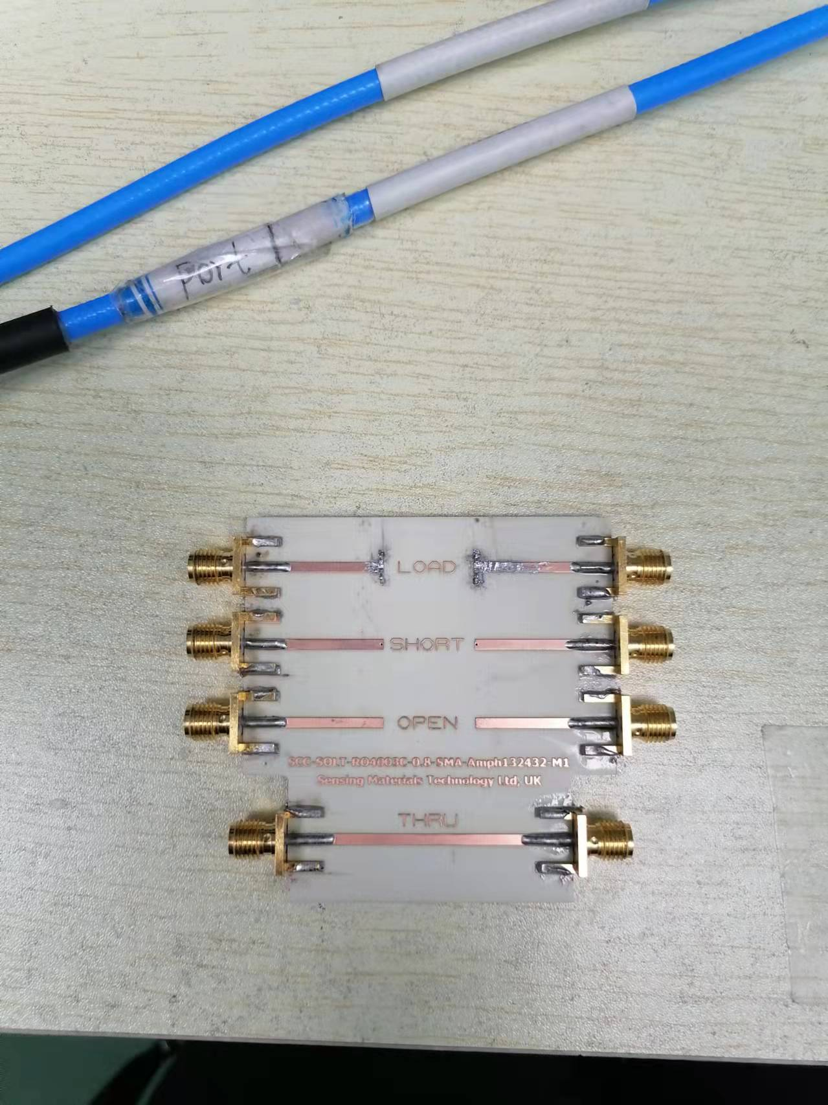

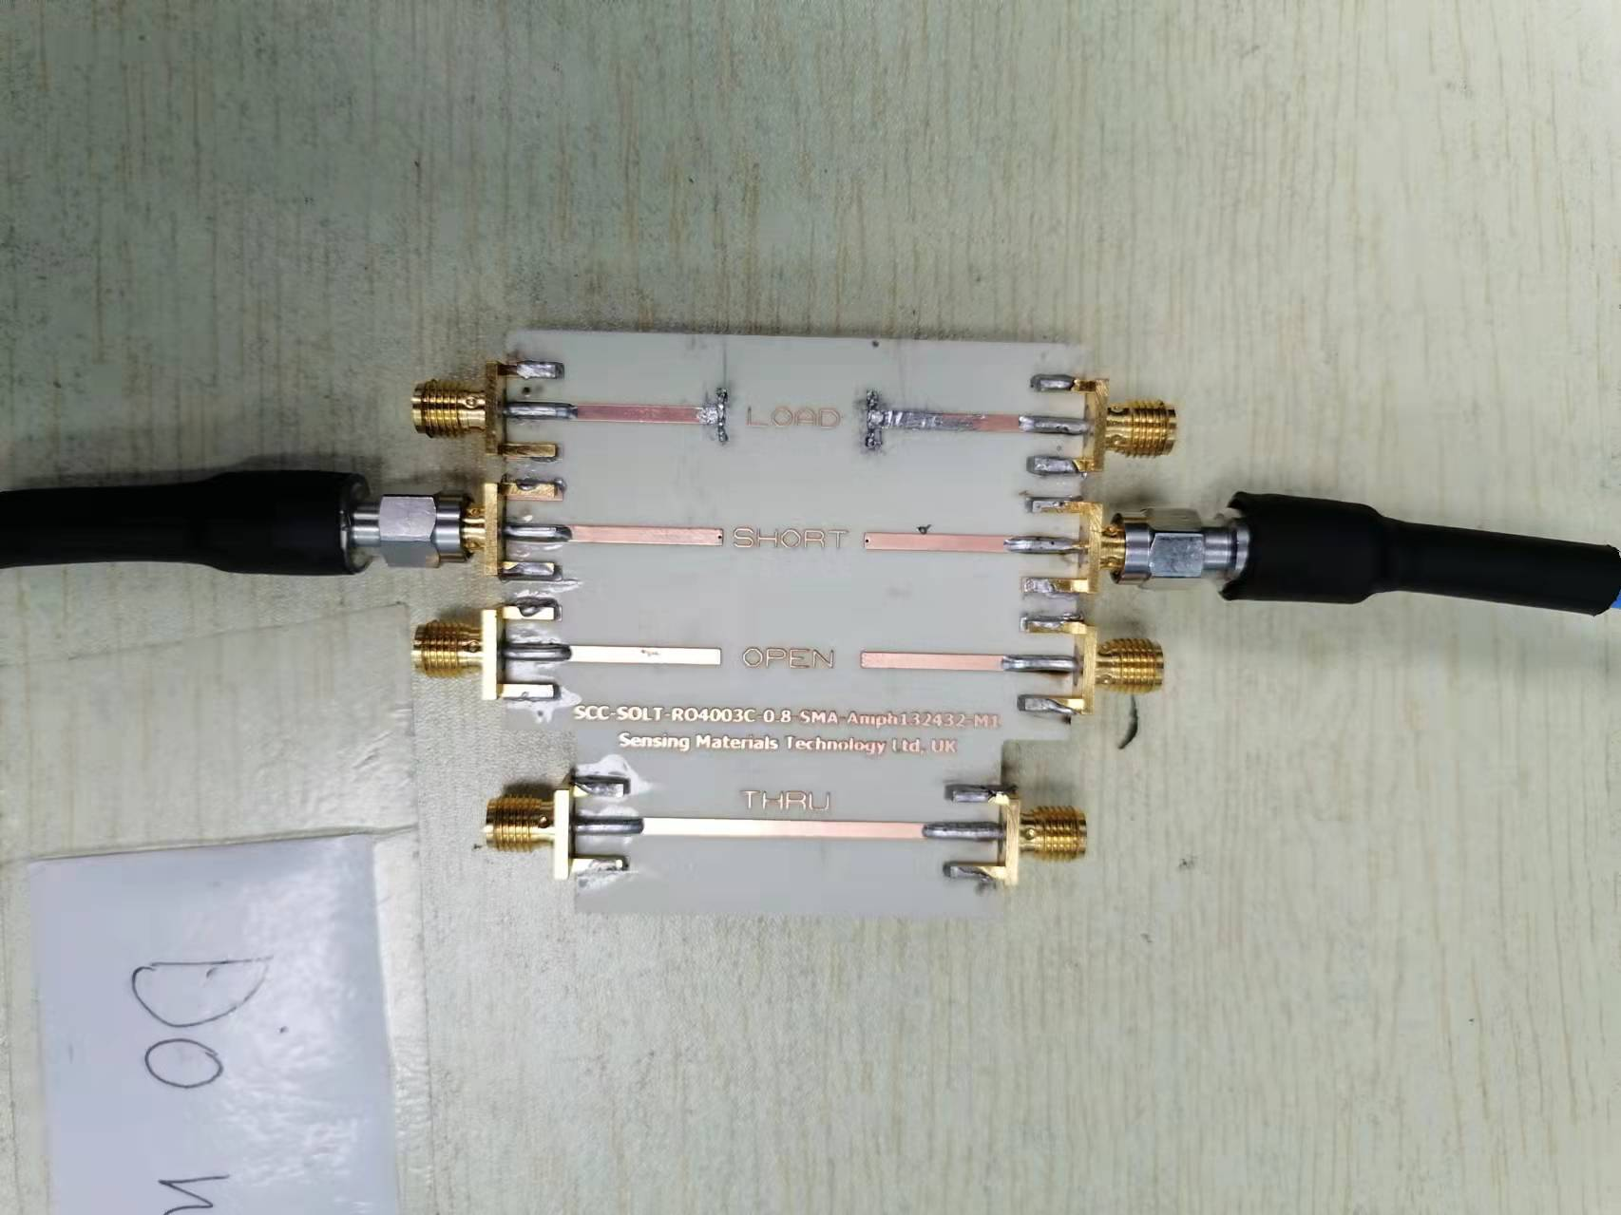

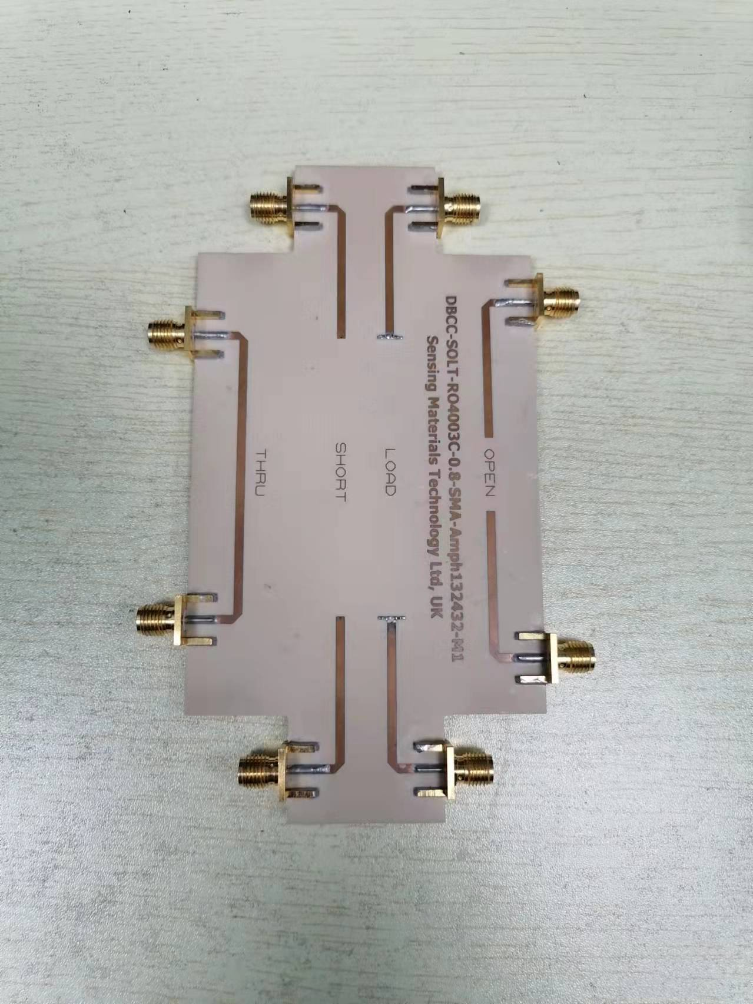

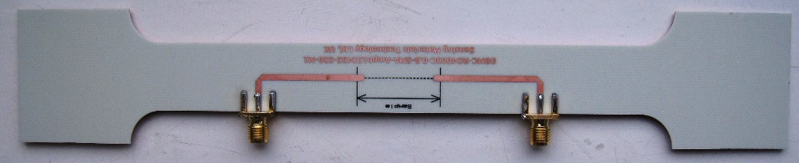

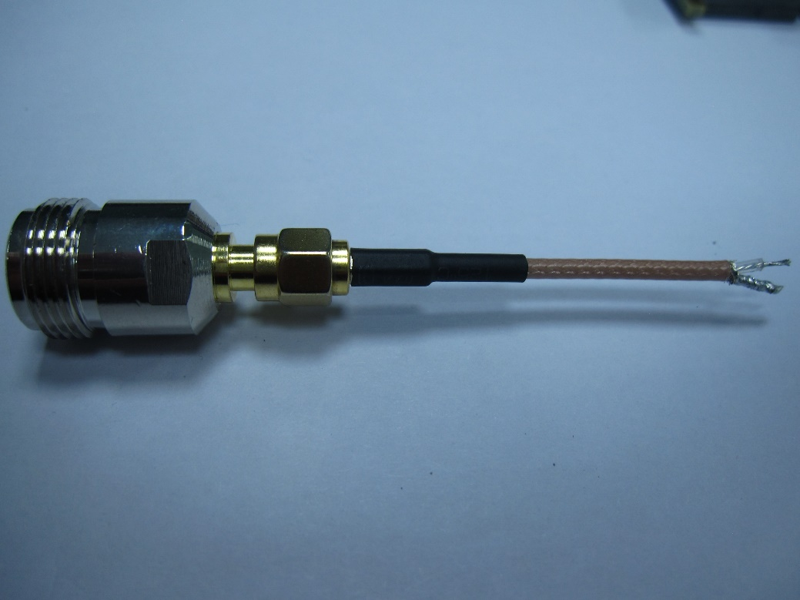

Examples of non-standards fixtures for testing samples: PCB cell with microstrips and

a piece of coaxial cable with free ends where the sample is attached

